Press contact:  CONEC Elektronische Bauelemente GmbH Registered office:  Katja Schade  Phone: 02941/765-350  Fax: 02941/765-65 | Ostenfeldmark 16  D-59557 Lippstadt  www.conec.com

Press release 01.05/2017

Title: CONEC IP67 USB 3.0 Connector Series / SuperSpeed-USB for use in harsh environments
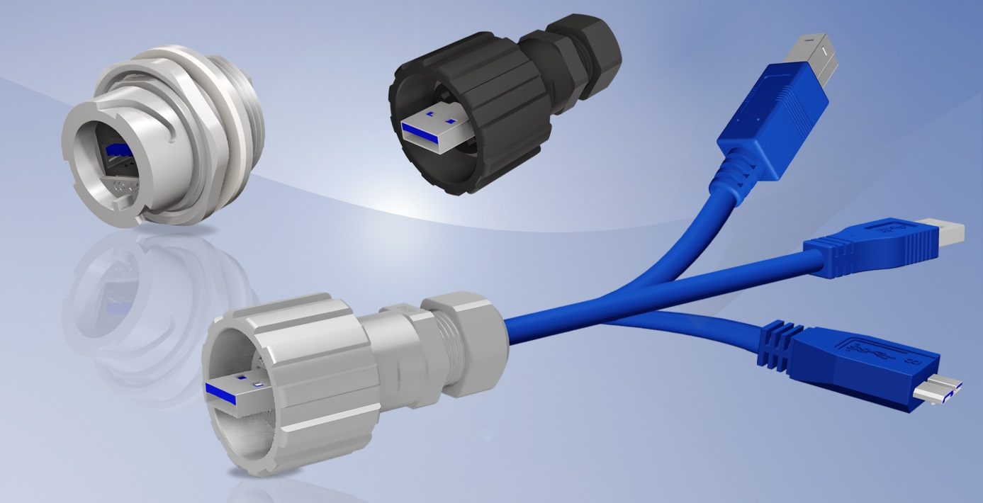
Caption: CONEC IP67 USB 3.0 Connector Series

The IP67 USB3.0 series is the new member to CONEC IP67 series connector family.

USB 3.0 provides data transfer rates 10 times faster than USB 2.0. Integrated into the CONEC bayonet locking housing the USB 3.0 connectors become suitable for industrial applications. The bayonet locking design allows a fast, simple and robust IP67 protected connection and ensures protection against environmental influences in rough conditions.

The new USB 3.0 Type A is plug compatible to USB 2.0 Type A. I.e. the Type A USB 3.0 connectors and sockets do fully accept all Type A connectors from the former generations. USB 3.0 Type B and Type Micro-B sockets are suitable to accept USB 2.0 Type B and Type Micro-B connectors, but vice versa those connections cannot be mated together.

The difference between USB 2.0 and USB 3.0 is that an additional signal pair allows full duplex data transfer, i.e. USB 3.0 can read and write data simultaneously at full speed. This is the first time a bidirectional data transfer is incorporated into the Universal Serial Bus.

A further improvement of USB 3.0 is the increased maximum unit load. USB 3.0 supports up to six devices with up to 150 mA load per device, i.e. a total load of 900 mA.

The IP67 USB 3.0 connector series is available in plastic and metallised plastic. The Type A / Type A panel mounted receptacles are suitable for front and rear panel mounting. The cable connector accepts cable diameter between 4.0 mm and 6.0 mm. Besides the single connector the following cable assemblies are available in different lengths:

• IP67 USB Type A to IP67 USB Type A
• IP67 Type A Plug to USB 3.0 Type A overmoulded (IP20)
• IP67 Type A Plug to USB 3.0 Type B overmoulded (IP20)
• IP67 Type A Plug to USB 3.0 Type Micro-B overmoulded (IP20)

To protect the connector against dirt and moisture in unmated condition, protection caps with tether are available.

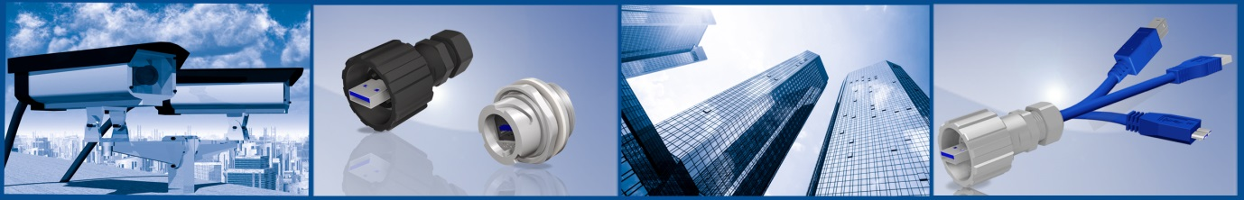

Fields of application:
• Automation technology
• Building automation
• Process Automation
• GPS navigation
• Industrial interfaces
• Cable Assembly
• Security and Monitoring Systems
• Communication Technology
• Blu-Ray Drives
• External Hard Drives for harsh environment

Benefits:
• Use in harsh environments due to protection class IP67
• Quick and easy bayonet locking type
• Data transmission up to 4.8 Gigabit
• Backwards compatible with USB 2.0
• Maximum unit load up to 900 mA

Produktdetails:

Technical data
Data transmission | up to 4,8 Gigabit
Locking type | Bayonet
Type of termination | Solder
Terminal cross-section | AWG 27 to AWG 22
Cable diameter | 4 mm to 6 mm
Contact plating | Gold over Nickel
Connector operating temperature | -40°C - + 85°C
Degree of protection in mated condition | IP67 according IEC 60529

