Press contact:  CONEC Elektronische Bauelemente GmbH Registered office:  Katja Schade  Phone: 02941/765-350  Fax: 02941/765-65 | Ostenfeldmark 16  D-59557 Lippstadt  www.conec.com

Press release 01.11/2017

Title: CONEC Product series M8x1 P-coded - The combination of superfast EtherCAT communication with
the 24 V power supply.
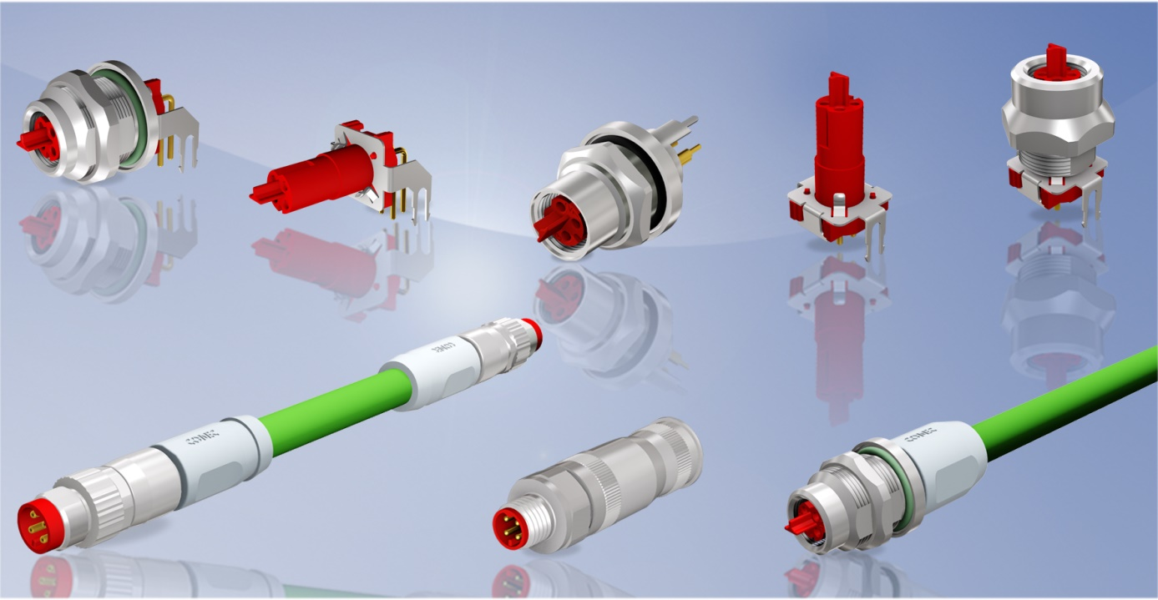
Caption: CONEC M8x1 Product series EtherCAT P

EtherCAT communication, which has been known up to now and is based on Ethernet transmission technology, is characterised in particular by its fast transmission speed (real-time Ethernet). This is necessary for many applications, e.g. synchronisation in the field of automation technology. The wiring technology is implemented with a 4-pole shielded M8x1 connector and a standard Ethernet cable, the power supply by a separate cable. A further development of the globally established and standardised EtherCAT technology has been implemented with EtherCAT-P by Beckhoff and the associated ETG (EtherCAT Technology Group). The special feature of EtherCAT-P is the combination of superfast EtherCAT communication with the 24V power supply. Data and power (Us) for system and sensor supply with 24V and 3A are provided on a two-wire data pair.
The second data pair provides data and the peripheral voltage (Up) for the supply of the actuators. This direct coupling of the supply voltage to the 100 MBit line for EtherCAT-P enables a compact and cost-effective device interface.

Since the supply lines are no longer required, this is referred to as a "one cable solution".
In order to make it impossible to connect with other standardized M8x1 connector systems, a new coding has been developed for this application and standardized in IEC 60176-2-114 under the term
"P - Coding". Special features of this coding are the red colouring of the contact carriers and the leading T-contour on the front face of the coupling contact carrier, which prevents connecting with other codings.

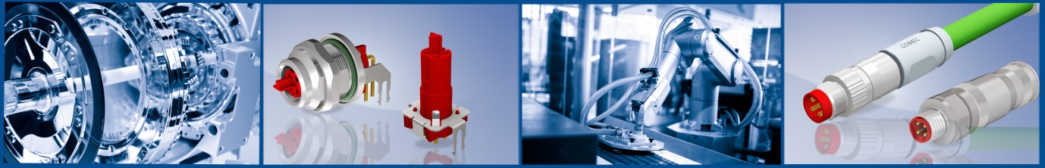

Connectors overmoulded:
Currently, shielded axial overmoulded designs with cable quality G6, TPU 4xAWG22, are available in the standard lengths. For the 100 MBit device connection almost exclusively male-male patch cords are used.

Connectors field attachable:
Field attachable connectors are available as female and male variants in axial design, either with screw (Female and Male connector) or crimp (male connector) termination.

Flanges for direct PCB mounting:
An extensive product range for device connection is available here, so that the user has many variable installation options. The continuous shielding from the flange housing to the circuit board is realised with a punched sheet metal plate. Moulded contact tongues form the radial connection to the flange housing, the connection to the printed circuit board is made by means of latching elements with subsequent soldering. The materials used are suitable for wave soldering. A special flange version is the version with moulded cable and a further plug on side B, preferably P-coded. Ideally, this can be used for wiring through a wall, e. g. a switch cabinet.
Fields of application:
• Drive technology
• Communication technology
• Automation technology
• Machine manufacturing
• Housing and device construction
• Control technology
• Industrial interfaces

Benefits:
• Very small connector system with small installation space for fieldbus
transmission technology
• Power and data on one data pair
• Variable installation and connection options on the device side
• Good chemical resistance of the connector
• High degree of protection IP67
• Robustness

Produktdetails:

No. of poles. | 4-pol.
Coding | P-Cod.
Rated voltage  Typical | 50V AC / 60V DC  24 V
Current rating | 4 A
Transmission characteristics | ISO 11801 IEC61158
Mating cycles | >=100
Temperature range | -20 °C ... +85 °C

