Polymer preparation system DULCODOS ULIa
Using polymers to optimise sludge dewatering
Every year several thousand tons of sewage sludge is produced in clarification plants during the various processes used to clean wastewater. Because disposing of this sludge via landfill or burning creates cost, operators try to produce as dry a residual sludge as possible. The generated digested sludge can be massively dewatered by producing and adding polymer solution with the aid of ProMinent’s metering system DULCODOS ULIa, which reduces costs in the disposal of residual sludge.
The metering system DULCODOS ULIa is a compact inline preparation station which converts liquid polymers into a fully activated solution. Featuring an integrated mixing and maturing chamber and metering pump adapted to the application, it is designed for extraction rates of 100 - 400 l/h at concentrations of 0.05 - 1% and a maximum back pressure of 4.5 bar.
Depending on the permitted back pressure, the metering system may be equipped with a peristaltic, solenoid or motor-driven metering pump. This meters the liquid polymer into a special mixing chamber, where the optimum amount of water is added to produce a matured and fully activated polymer solution with a maturing time of 15min. Thanks to its compact design, the metering system saves space at the installation location and offers numerous setup options.
DULCODOS ULIa is very easy to use thanks to an integrated touchpanel; allowing proportional metering and the option of setting polymer preparation rates in l/h with ease. With this optimum process control it ensures reliable operation, which conserves resources.
Alongside its use in sludge dewatering and sludge thickening, DULCODOS ULIa can also be found in industrial and municipal wastewater treatment as well as drinking water preparation.
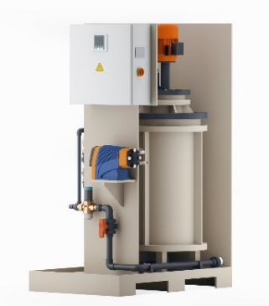

Polymer preparation system and metering system DULCODOS ULIa, especially for preparing a complete liquid polymer solution. The system is designed for extraction rates of 100-400 l/h at a maximum back pressure of 4.5 bar.



The ProMinent Group is a manufacturer of components and systems for metering technology as well as a reliable solution partner for water treatment. The Group headquarter is based in Heidelberg, Germany. More than 2,700 employees in about 50 own sales and service companies as well as 11 production sites work hard to provide individual solutions and high-quality services to ProMinent customers. More information: www.prominent.com.

ProMinent Group
ProMinent Germany
ProMinent Group

