ProMinent solutions for the pulp and paper industry
How paper manufacturers safely store, empty and meter chemicals

To improve the properties and quality of paper, paper and pulp manufacturers use chemicals such as these:
- Retention agents: Paper is initially just an extremely watery pulp made of fibres and water. Retention agents ensure that the water is removed during paper production without the fibres also disappearing.
- Dyes: To compensate for the natural yellow tint of paper, dyes are added to the base paper pulp to emphasise the blue content. This leads to the brilliant, well-known white colour of paper.
- Biocides: In the paper machine, biocides prevent slime formers and thus the dreaded and expensive formation of lumps. This allows the process to run smoothly.
The chemicals are often stored in so-called intermediate bulk containers (IBCs). These containers are changed as soon as the chemicals are used up. The container change must take place safely and without interrupting the flow of substances so that no one is endangered, and production continues smoothly.
With DULCODOS SAFE-IBC from ProMinent, paper manufacturers can safely store and empty their chemicals and meter them without interruption. The special metering and emptying station for intermediate bulk containers (IBCs) ensures almost complete residual emptying.

The advantages of using ProMinent’s DULCODOS SAFE-IBC for paper and pulp manufacturers:
- High occupational safety
The DULCODOS SAFE-IBC is safely set up on a special, under-ride collection tray construction. Drip quantities can thus be reliably collected and cannot escape at the installation site. The chemical container can be conveniently changed while the process is supplied without interruption from the 200-litre intermediate container.
- More process reliability
An integrated buffer container enables uninterrupted metering with sufficient time for changing the container in the process. Optionally, a fill level measurement with an alarm message can be used.
- Compliance with laws and regulations
The station complies with the amended legislation for liquids hazardous to water according to the German AwSV (Ordinance on Installations for Handling Substances Hazardous to Water) and has a valid DIBt approval (German Institute for Building Materials Technology) for all substances named there in media list 40.
- Sustainability
Due to the almost complete emptying of the IBC, virtually no waste or residual chemicals remain.
Experience DULCODOS SAFE-IBC live at our booth, no. 40 in Hall ‘Nord’ at the ZELLCHEMING-Expo tradeshow, from 29th of June till 1st of July 2022 in Wiesbaden.
You can find further information here: Metering and emptying station DULCODOS® SAFE-IBC - ProMinent

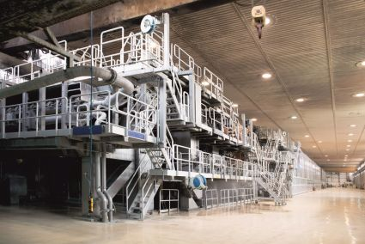
Caption 1: During paper production, the used chemicals have to be refilled on a regular base. ProMinent technology ensures that the production continues smoothly without interruption (Image: ProMinent).
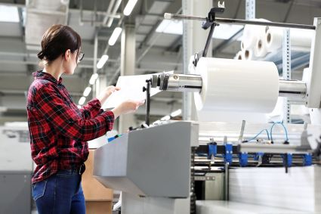
Caption 2: Reliable partner for the paper industry: ProMinent technology enables uninterrupted paper production processes for high-quality papers (Image: ProMinent).
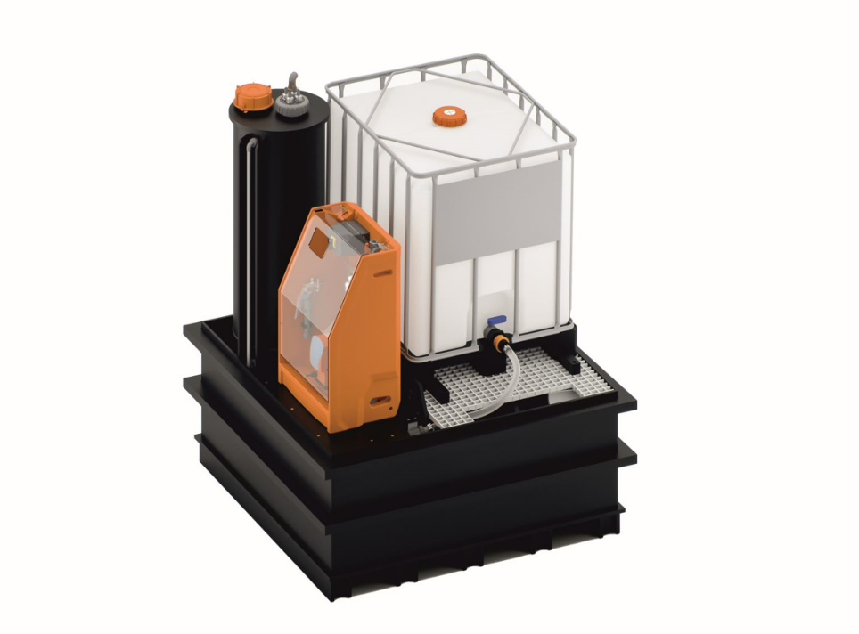
Caption 3: With DULCODOS SAFE-IBC, the special metering and emptying station for intermediate bulk containers (IBC) from ProMinent, paper manufacturers can safely store and empty their chemicals and meter them without interruption (Image: ProMinent).
The ProMinent Group is a manufacturer of components and systems for metering technology as well as a reliable solution partner for water treatment. The Group headquarter is based in Heidelberg, Germany. More than 2,700 employees in about 50 own sales and service companies as well as 11 production sites work hard to provide individual solutions and high-quality services to ProMinent customers. More information: www.prominent.com.



ProMinent Group
ProMinent Germany
ProMinent Group

