DULCOTEST sensors PAA 2-3E and PEROX H-3E
New sensors for measuring H₂O₂ and PAA
ProMinent is expanding its product range to include new sensors for measuring peracetic acid (PAA) and hydrogen peroxide (H₂O₂) without cross-sensitivity to each other. The measured variables are recorded selectively – without distortion, even at low concentrations.
Hydrogen peroxide and peracetic acid can be used for disinfection in many areas of industry. They are increasingly being used instead of chlorine in areas that come into contact with people and nature because they break down into environmentally friendly water, oxygen and acetic acid after use. This makes them ideal for water disinfection in the pharmaceutical industry, medical technology, the food and beverage industry, plant cultivation and waste water treatment.
DULCOTEST PAA 2-3E and PEROX-H-3E sensors are used to measure the PAA and H₂O₂ concentrations during disinfection. Both sensors work based on the amperometric measuring principle. This uses three electrodes, allowing long-term stable zero points and accurate measurements even at low concentrations. The electrodes are resistant to salts, acids, lyes, surfactants and films of dirt. Integrated transmitters and a reliable signal cable connection with a secure contact closure ensure convenient installation.
The two versions of the PAA 2-3E sensor type detect peracetic acid concentrations in the range of 0.02 to 20.0 mg/l without cross-sensitivity to hydrogen peroxide. The sensor is typically used for waste water disinfection with PAA when lower peracetic acid limit values have to be monitored in the waste water to be released.
The new PEROX H-3E sensor is ideal for measuring hydrogen peroxide without cross-sensitivity to free chlorine and peracetic acid. It is suitable for use in fast control processes with short response times – even in moderately contaminated water – for reliable measurements from 0.20 ppm H₂O₂. Four different versions of the product cover measuring ranges of up to 10, 50, 200 and 500 ppm.
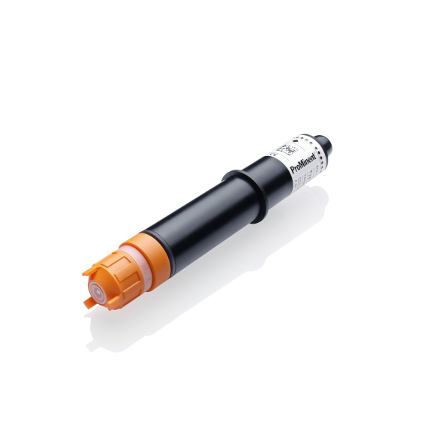
The new DULCOTEST sensors PAA 2-3E and PEROX H-3E from ProMinent measure peracetic acid and hydrogen peroxide without cross-sensitivity to each other.



The ProMinent Group is a manufacturer of components and systems for metering technology as well as a reliable solution partner for water treatment. The Group headquarter is based in Heidelberg, Germany. More than 2,700 employees in about 50 own sales and service companies as well as 11 production sites work hard to provide individual solutions and high-quality services to ProMinent customers. More information: www.prominent.com.

ProMinent Group
ProMinent Germany
ProMinent Group

