|  |  |  |
| --- | --- | --- |
| Press contact:  **CONEC Elektronische Bauelemente GmbH**  Katja Schade  Phone: 02941/765-350  Fax: 02941/765-65 | Ostenfeldmark 16  D-59557 Lippstadt  www.conec.com | Conec Logo |

Press Release 01.06/2016

### Title: CONEC M12x1 Insulation body/Sockets SMT/THR • X-coded • 10 Gbit/s

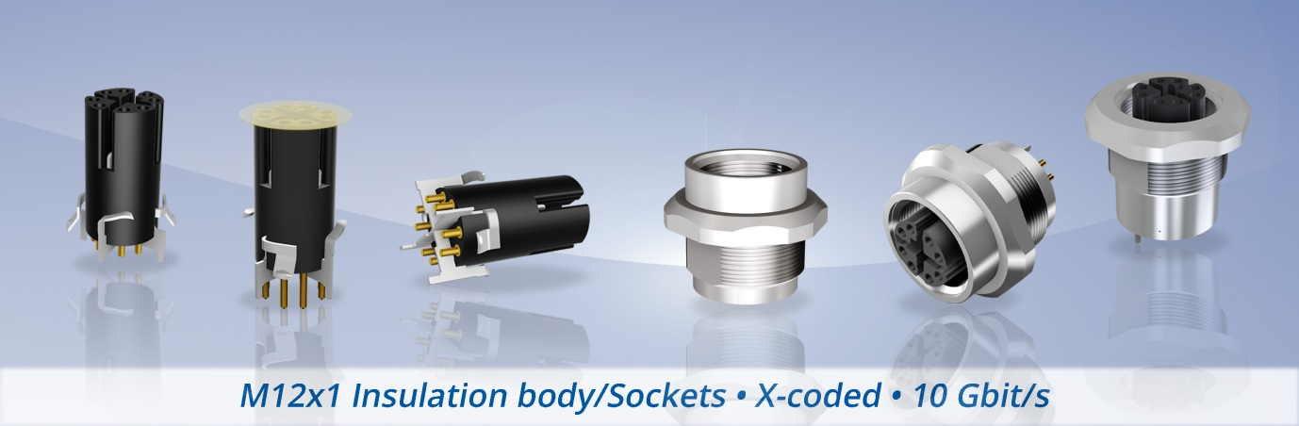



As a result of the permanent growth of digital communication and the massive increase in data volumes, especially in the industry 4.0, it is necessary to ensure faster and broader transmission of information. CONEC makes a step in this direction with the new X-coded connector family size M12x1 which is designed for data transmission according to standard CAT 6A.

M12x1 X-coded was designed for 10 GB/s data transmission, SMT surface mounting and THR design. THR allows surface mounting as well as reflow process ability. This soldered version has the well-known stability of wave soldering.

The user can mount the board equipped with the insulation body in different socket geometries. CONEC sockets are suitable for combined mounting and ideal for designs where the M12x1 thread of the housing is directly moulded on, thus creating maximum design flexibility.

The already mentioned characteristic way of mounting it in different socket geometries is the proprietary main feature of this innovative connector. The dual and symmetrical arrangement of the contact springs refines the previous shield concepts through an axial and radial connection to the socket side and is the result of the requirement of low-resistance shield transmission.

If, due to the ever-smaller construction space requirements, the user has to do without the radial or the axial socket connection, it is possible now to use only one of the two contact types. Due to the radial shield concept, a considerable tolerance range can be compensated for during installation without negative effects on the contact resistances. Electromagnetic separation of the four pairs of wires according to CAT 6A is still 100%.

Another benefit is the flexible contact placement type with the mating connector. It can ensure electromagnetic separation of the pairs of wire by means of a massive shield body or suspended counter elements. Simultaneous overlapping and touching of the elements results in excellent shield transmission between two connectors.

Automated assembly of the connector is still possible, even with the spring elements. The board assembler can rely on a suction system and use the adhesive pad applied by CONEC to grasp the connector for the assembly.

By default, the degree of protection in mounted condition to housing is IP67, on the connector face in unscrewed condition IP20.

**Fields of application:**

• Automation

• Building automation

• Communications

• Industrial interfaces

**Benefits:**  
• Time saving due automated assembly

• Congenial to mount with differently flange geometries

• Low forces on the board

• Low contact shielding resistances

• Big tolerance compensation between board and housing

• Also mountable without CONEC-sockets

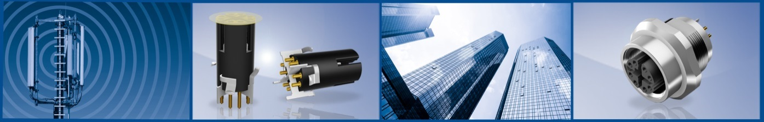

**Produktdetails:**

|  |  |  |  |  |  |  |
| --- | --- | --- | --- | --- | --- | --- |
| No. of poles | Coding | Termination | Mounting style | Rated voltage | Current rating | Installation height |
| 8-pos. | X | SMT, THR | Front panel mounting | 48 V | 0,5 A @ 40°C | 9 mm, 13 mm |