ProMinent at the DrinkTec 2022
Metering and disinfecting in the beverage industry
From 12 to 16 September 2022, DrinkTec in Munich will be the meeting place for the beverage industry. ProMinent will be there. You will find us in Hall B3 at Stand 312. With innovative metering systems and hygiene solutions, we make beverage production and filling easier for our customers.
Our highlights
Metering technology and water treatment
- The DULCODES LP UV system, specially designed for use in the food and beverage industry, complies with Hygienic Design, is CIP-capable and equipped with FDA-compliant materials. It belongs to the series of ProMinent UV systems that are the only ones certified according to the new DIN:19294 2020-08 test standard.
- The DULCODOS metering system is used for metering chemicals with high precision. It has a modular design and can be used flexibly in a wide range of applications. The stainless steel version is ready for connection and can therefore be used immediately in the food and beverage sector.
- The motor-driven diaphragm metering pump Sigma in hygienic design enables precise and hygienic metering. All materials of the pump unit that come into contact with the media are designed to be physiologically harmless in accordance with FDA and EN Directive 1935/2004.
- With the new radar level sensor DULCOLEVEL, we offer a complete solution for chemical management in combination with the secure IIoT platform DULCONNEX and a convenient app configuration.
- Safe storage, emptying and uninterrupted metering of chemicals: This is easily achieved with DULCODOS SAFE-IBC, a special metering and emptying station for intermediate bulk containers (IBC) with almost complete residual emptying.
- The DFXa and DFYa peristaltic metering pumps offer precise metering of viscous and solids-containing media up to 410l/h. A matching FDA-compliant hose is available for the beverage and food industry.
Service
- With our new Smart Support solution, our service experts can quickly and easily look at our customers' equipment, even if we are not on site. Thanks to video chat and live transmission, we explain smartly and efficiently how to fix a problem.
...and other new developments from our company.
Visit us at DrinkTec in hall B3 at stand 312: drinktec 2022 (prominent.com)
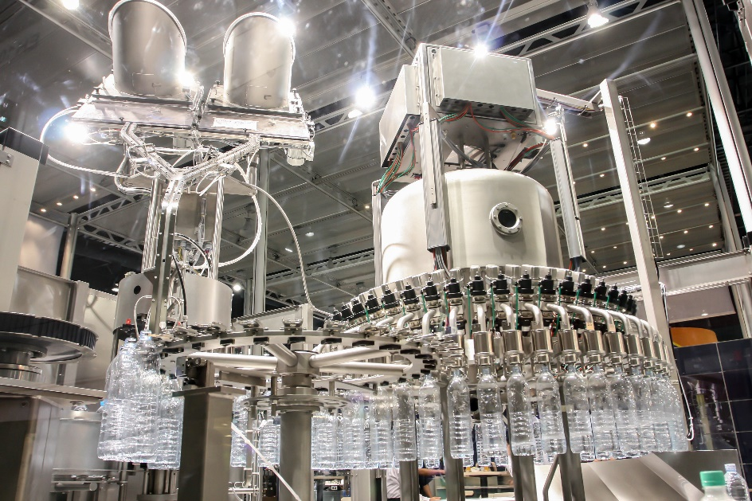
Caption: ProMinent offers innovative metering systems and hygiene solutions for the beverage industry and will be showing them at DrinkTec in Hall B3, Stand 312 (Image: © Fotolia).



The ProMinent Group is a manufacturer of components and systems for metering technology as well as a reliable solution partner for water treatment. The Group headquarter is based in Heidelberg, Germany. More than 2,700 employees in about 50 own sales and service companies as well as 11 production sites work hard to provide individual solutions and high-quality services to ProMinent customers. More information: www.prominent.com.

ProMinent Group
ProMinent Germany
ProMinent Group

