Press contact:  CONEC Elektronische Bauelemente GmbH  Katja Schade  Tel.: 02941/765-85  Fax: 02941/765-65 | Ostenfeldmark 16  D-59557 Lippstadt  www.conec.com

Press Release 01.09/2015

Title: CONEC SlimCon IP67 D-SUB connectors - Extremely small installation space requirements meet outstanding mechanical robustness and protection
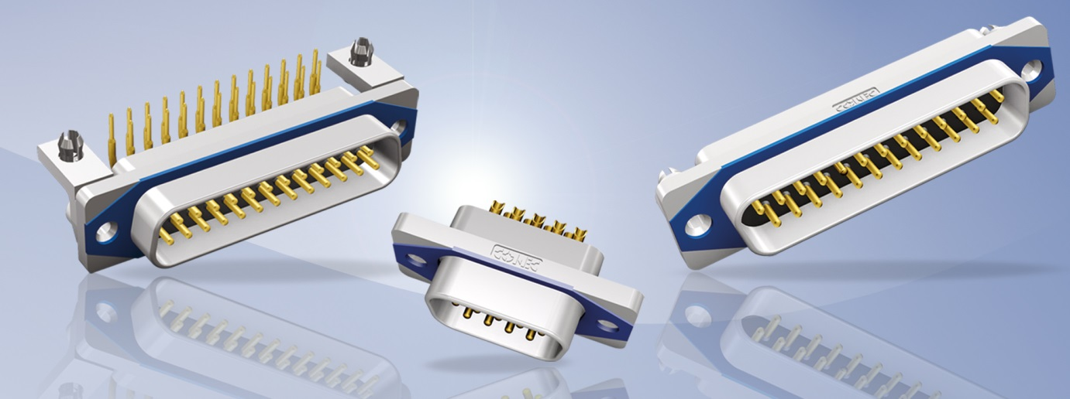
Caption: CONEC SlimCon IP67 D-SUB connectors

CONEC SlimCon is the youngest member of the IP67 D-SUB connector family. The CONEC SlimCon series are very compact designs of IP67 tight D-SUB connectors with extremely small installation space requirements. The panel cut-out for the CONEC SlimCon series corresponds to that of other D-SUB connectors, so no new panel cut-outs are required and it is also possible to switch from standard IP20 systems to the IP67 CONEC SlimCon series.

The one-piece zinc die-cast nickel plated shell provides - similar to the CONEC Solid Body series - outstanding mechanical robustness and protection.
CONEC SlimCon connectors are designed for back panel mounting and are mechanically in contact with the panel on 4 surfaces provided for that purpose. Sealing to the shell is achieved by a blue gasket and due to the 4 contact surfaces, contact pressure at the sealing will always be the same. Thus, excess pressure at the sealing is avoided and safe assembly at the customer’s is ensured. As far as we know, this feature is offered by no other manufacturer for the D-Sub range.
The CONEC SlimCon series is offered for the three sizes of 9-, 15- and 25-pole models. Subsequent extension to sizes of 37- and 50-pole models is possible, if required for interesting projects.
In addition to the back panel mounting variant, we also offer a variant with open threaded insert. This variant may be overmoulded at the customer’s and thus provides an overmoulded cable version in IP67 tight design. An appropriate jack bolt is also offered.
Fields of application:
• Drive technology
• Automation technology
• Communcations
• Military
• Security- and surveillance systems
• Use in harsh environments
Features:
• One-piece zinc die-cast shell
• 3.18 in PCB footprint
• Small dimensions (extremely small installation space requirements)
• Version with open 4-40 UNC thread for cable assembly and
overmoulding
Kompaktes Design
• Freie Konfektion im Feld
• Demontierbar
•
•
•
•

Productdetails:
No. of poles | Gender | Termination | Current  rating | Thread | Temperature range | Mounting style | Degree of protection  * in mamted condition
9, 15, 25 | Male, Female | Solder pin straight, Solder pin angled, Solder cup | 5 A | 4-40 UNC | -40°C bis + 105 °C | Back panel mounting | IP67

