Press release 23EF18 EN
Trade Shows Current Mai 2018
Trade fair Schüttgut starts in november under the new name SOLIDS Dortmund
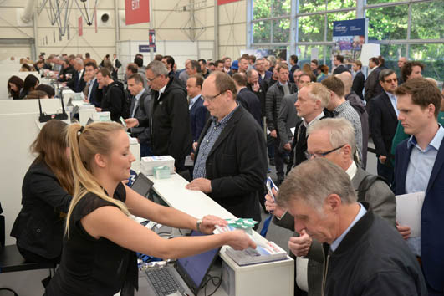
SCHÜTTGUT now called SOLIDS Dortmund
Kontakt und Informationen:
Ina Sunkel
Marketingleiterin
Easyfairs Deutschland GmbH
Balanstraße 73, Haus 8
D-81541 München
Tel. +49 89 127 165 127
ina.sunkel[at]easyfairs.com
www. easyfairs.com
Text + Bilder unter www.pressearbeit.org

(Dortmund) SCHÜTTGUT renamed: as of 2018, Germany’s pre-eminent trade show for granules, powders and bulk solids technologies will also be known domestically as SOLIDS Dortmund. With this name change, organiser Easyfairs acknowledges the show’s growth as well as its increased international significance. More than 500 exhibitors and some 7000 visitors are expected on 7 & 8 November, when the spotlight is focused on the latest technology for the production and handling of bulk material.
“With the new name SOLIDS Dortmund, we’re recognising the consistent growth and ever-increasing internationalisation that has taken place over the course of the last eight editions of Schüttgut,” emphasises Daniel Eisele, Group Event Director for organiser Easyfairs. On 7 & 8 November 2018, the ninth trade show for granules, powders and bulk solids technologies – and the first to run officially under the title SOLIDS – will take place at the Messe Dortmund. Over the years since its premiere in 2006, the share of international exhibitors has risen to nearly 20 percent, and amongst visitors to about 12 percent.

One of the shows in Europe’s largest show series
The new name, SOLIDS Dortmund, also underscores the show’s affiliation with Europe's largest series of trade shows for granules, powders and bulk solids technologies. Together with its sister events SOLIDS Antwerp, SOLIDS Rotterdam, SOLIDS Zurich, SOLIDS Krakow and SOLIDS Russia, Dortmund has long been a pillar of the Solids European Series (SES).
The new name will be accompanied by a new logo for SOLIDS Dortmund. It consists of three nested hexagons, representing the three types of bulk solids, i.e. stone, granules and powders. Its six corners stand for the six SES shows. The broad approval with which the new name and logo have been received is summarised by Professor Rainer Barnekow from the Life Science Technologies Department of the Hochschule Ostwestfalen-Lippe: “I’m delighted with the new name SOLIDS. Solids includes not only coarse bulk goods but also powders and finer-grained materials, and this is exactly what you’ll find at the trade show. Since the show has become more international, an English name is the ideal choice.”

A concept encompassing exhibitions, forums and conventions
Along with SOLIDS, the fifth edition of RECYCLING-TECHNIK Dortmund will also open its doors in Dortmund's exhibition halls this November. The two shows will be accompanied by the 4th German Fire and Explosion Protection Congress and the 8th URBAN MINING® Congress, which will both be held in parallel.
327 Wörter, 2.557 Zeichen

Text und Bilder auch unter www.pressearbeit.org

Facts and information for 2018
«SOLIDS Dortmund» in parallel with «RECYCLING-TECHNIK Dortmund»
Dates: Wednesday and Thursday, 7 & 8 November 2018
Venue: Messe Dortmund, Halls 4, 5, 6 + 7, Rheinlanddamm 200, 44139 Dortmund
Opening hours: Wednesday, 9:00-17:00
Thursday, 9:00-17:00
Ticket price: Two-day-online-ticket costs €30 for both shows
Organiser: Easyfairs Deutschland GmbH, Balanstr. 73 / House 8, 81541 Munich
Show websites: www.solids-dortmund.com and www.recycling-technik.com

About SOLIDS Dortmund
SOLIDS Dortmund has established itself as a fixture in the diaries of industry professionals. It has become the most important business and innovation platform for bulk solids technologies, covering the entire value chain of process engineering for granules, powder and bulk solids technologies. On display are machinery and techniques for incoming goods as well as the handling (sieving, filtering, dosing, weighing, measuring) and processing (crushing, agglomeration, chilling, heating, separating, mixing) of solid goods, through to in-house mechanical or pneumatic conveyance and procedures for filling, packing, storage, transport and shipment of those goods. Solids technologies are important to such diverse industries as foodstuffs, chemicals, pharmaceuticals, cosmetics, plastics, metals, logistics, agriculture, construction and mining. Specialists and procurement professionals in these fields will find machinery, components and complete solution systems.
For further information, see www.solids-dortmund.com

About RECYCLING-TECHNIK
RECYCLING-TECHNIK Dortmund ran for the fifth time as important industrial trade show for recycling technologies. At the exhibition, 240 suppliers covered four halls presenting solutions from the entire spectrum of recycling technologies. Machinery and technical components for recycling and disposal of waste are the focus areas of the show, especially: balers, shredding machines, sorting systems and crushers; sieving and separating machines; and conveyor systems. The solutions are designed for recycling organisations, recycling depots and disposal companies as well as for companies with in-house recycling facilities from the plastics, food processing, metal and construction industries, logistics, agriculture, chemicals and pharmaceuticals.
For further information, see www.recycling-technik.com
The two shows are co-located. At the previous edition, on 10 & 11 November 2017, 500 exhibitors and 6731 visitors took part.

SOLIDS European Series
With shows in Antwerp, Dortmund, Krakow, Moscow, Rotterdam and Zurich, the SOLIDS European Series counts as Europe's most extensive solids network. In total, across the six events some 1,100 exhibitors will meet with 15,000 trade visitors.
SOLIDS Russia 29 & 30 May 2018 Expocentre Moskau
SOLIDS Kraków 10 & 11 October 2018 EXPO Kraków
SOLIDS Antwerp 17 & 18 October 2018 Antwerp Expo
SOLIDS Dortmund 07 & 08 November 2018 Messe Dortmund
SOLIDS Rotterdam 02 & 03 October 2019 Rotterdam Ahoy
SOLIDS Zurich 12 & 13 February 2020 Messe Zürich

About Easyfairs
Easyfairs enables communities to “visit the future” at must-attend events that anticipate their needs and present solutions in the ideal format.

The group currently organises 218 events in 17 countries (Algeria, Belgium, China, Denmark, Emirates, Finland, France, Germany, the Netherlands, Norway, Portugal, Singapore, Spain, Sweden, Switzerland, the United Kingdom and the United States). Easyfairs also manages 10 events venues in the Benelux, Netherlands and Nordic region (Ghent, Antwerp, Namur, Mechelen-Brussels North, Hardenberg, Gorinchem, Venray, Stockholm, Gothenburg and Malmö).

In the DACH region, these events include Automation & Electronics (Zurich), Empack (Dortmund and Zurich), Label & Print (Zurich), Logistics & Distribution (Dortmund and Zurich), Maintenance (Dortmund and Zurich), Packaging Innovations (Zurich), Pumps & Valves (Dortmund and Zurich), Recycling-Technik (Dortmund) and Solids (Dortmund and Zurich).
The group employs more than 750 people and generated revenues exceeding €160 million for its financial year 2016-2017.

Easyfairs strives to be the most adaptable, agile and effective player in the events industry by employing committed individuals, deploying the best marketing and technology tools and developing strong brands. Visit the future with Easyfairs.
For more information, visit our website www.easyfairs.com

figures SOLIDS Dortmund 2018
Mit 2 Klicks zu Text und Bild unter www.pressearbeit.org.
Bild Nr. 23-01 EF_SolidsDO-Eingang.jpg.

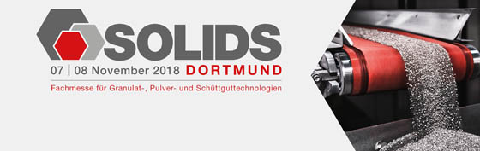
Bild Nr. 23-02 EF_SolidsDO-Logo.jpg.

