|  |  |  |
| --- | --- | --- |
| Press contact:  **CONEC Elektronische Bauelemente GmbH**  Katja Schade  Phone: 02941/765-350  Fax: 02941/765-65 | Ostenfeldmark 16  D-59557 Lippstadt  www.conec.com | Conec Logo |

Press Release 01.05/2016

### Title: Connectors for security and surveillance systems

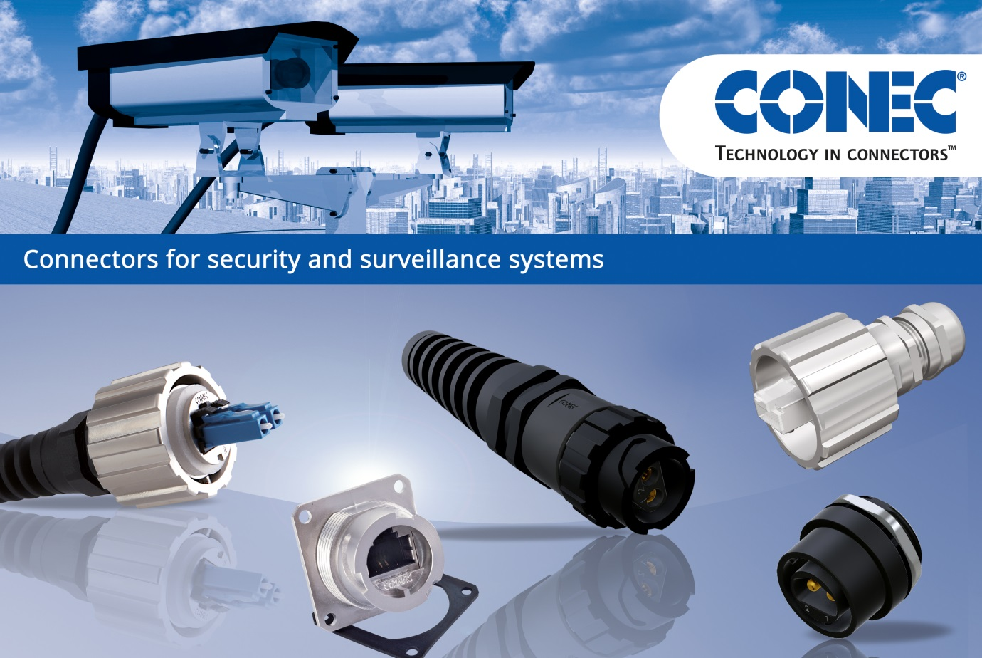



Camera surveillance systems experience a growing interest from politics and economy at the present time. Especially in public places such as city centers, train stations, airports or major events the awareness of video surveillance rises. Reliable data and power transmission are the guarantee for safe and complete video surveillance. An unexpected failures always means a loss of video recording and time-consuming removal of the disturbance.

The requirements on the necessary connection solution in these applications arise from the installation site, for example:

• It is an external application; the laying of the distribution box and cables is in the underground

• The distribution box is exposed to weather conditions (moisture, temperature fluctuations)

• The underground placement complicates the maintenance after installation

CONEC with its waterproof products with bayonet locking meet all requirements best. The simple and safe connection of IP67 connectors prevents the occurrence of sealing problems, and thus ensures maximum process reliability after installation. Once installed, the connection in the distribution box withstands the harsh environment and all its weathers – as consequence downtimes are prevented and maintenance are reduced to the minimum.

The identical cutouts for RJ45, power and fiber optic LC duplex enable flexible use of different plug connectors versions within one system, which is accompanied by a reduction of installation effort.

Another benefit is the flexible contact placement type with the mating connector. It can ensure electromagnetic separation of the pairs of wire by means of a massive shield body or suspended counter elements. Simultaneous overlapping and touching of the elements results in excellent shield transmission between two connectors.