Press contact:  CONEC Elektronische Bauelemente GmbH Registered office:  Katja Schade  Phone: 02941/765-350  Fax: 02941/765-65 | Ostenfeldmark 16  D-59557 Lippstadt  www.conec.com

Press release 01.08/2016

Title: CONEC - the specialist for filter connectors
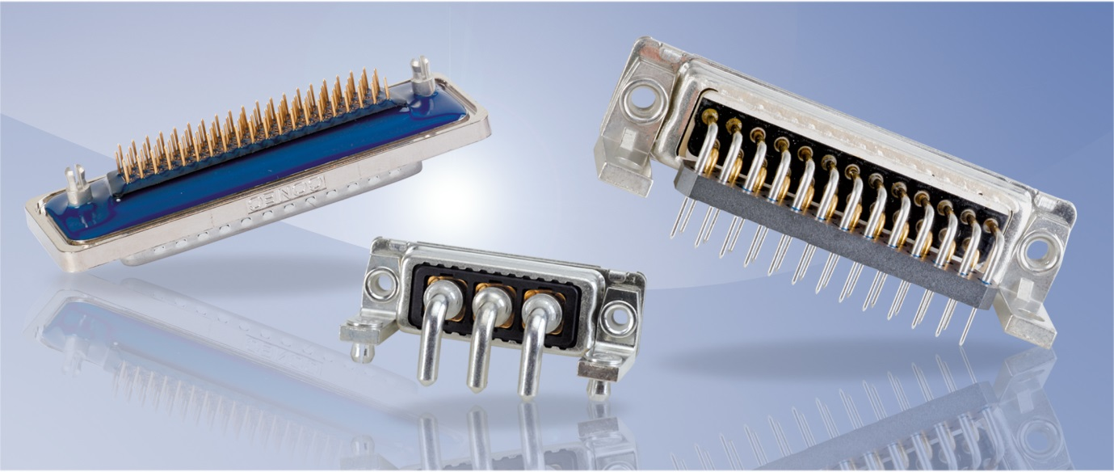
Caption: CONEC filter D-SUB connectors

Since 1985, CONEC has been one of the world's leading suppliers of connectors with integrated filter technology.
Among others, CONEC uses the patented planar filter technology which ensures high-quality filtering in high frequency ranges.

With increasing data transfer rates and operating frequencies, it becomes more and more important to ensure the function of electrical equipment and installations in the mutual environment and trouble-free operation.

Thus, connectors with integrated low-pass filters should be used at the interfaces.
Filtering interferences at the interface prevents that the interferences get into the system and it contributes to the miniaturization of the systems, since no additional space on the system board must be used for discrete filter elements.

The connecting dimensions of the CONEC filter connectors are usually compatible with unfiltered connectors. Thus, there is also the possibility of expanding systems by adding filtered interfaces subsequently without much effort.

CONEC provides the so-called C-filter as standard. In this single-stage low-pass filter, each contact of the connector is connected with a capacitor to the connector housing (ground). Other options that can be used depending on the problem to be solved are the two-stage LC and the three-stage PI filters (C-L-C), which are also available in various cconnector configurations in the standard product range.

The difference of the different filter types is their performance. At a far distance between operating frequency and interference frequency, a single C-filter is often a sufficient solution for the EMI problem. If the distance between operating frequency and interference frequency is smaller, multistage filter configurations are used. A C-filter suppresses the interferences from the "3dB point" with approx. 20 dB, an LC filter with approx. 40 dB and a PI filter with approximately 60 dB per decade.
Features:
• Filtering directly at the interface
• No PCB redesign required
• Filter adapter to upgrade existing systems
• Up to three-stage low-pass filters
• Selective filtering
• Mixing capacities
• Low magnetic versions

Fields of application:
• Medical technology
• Telecommunications
• Testing and diagnostic equipment
• Power supplies
• Industrial interfaces
• Military

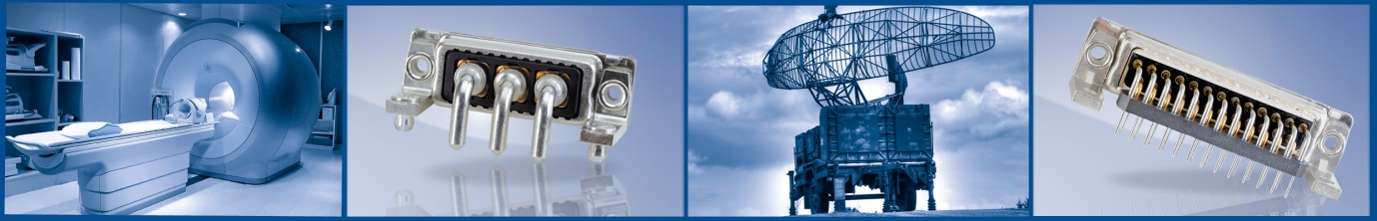

Product details:

