Primary Media Contact:
Advantech Europe BV
Stephanie Stadlberger
Phone: +49 (0) 89 12599 1021
Stephanie.Stadlberger@advantech.de

Advantech RTX COM Module with Freescale ARM Cortex™-A9 i.MX6 Processor for Ruggedized Applications

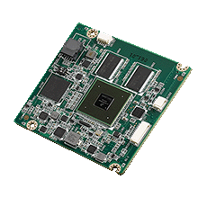
July, 2014, Taipei–Advantech (2395.TW), a global leader in the embedded computing market, is glad to announce the launch of its new RISC RTX COM module—ROM-3420 powered by the Freescale ARM® Cortex™-A9 i.MX6 Dual 1GHz high performance processor. Advantech introduced the RTX 2.0 (RISC Technology eXtended) specification which is a RISC standard platform form factor designed for demanding applications. Through its innovative mechanical and electrical design, ROM-3420 designed with RTX 2.0 can effortlessly perform complex and challenging tasks in demanding environments such as military, logistics, transportation/fleet management and many other fields.

Flexible I/O Interface and Better Reliability for Harsh Environments
ROM-3420 module integrates the Freescale® i.MX6 Cortex™-A9 1 GHz ultra low power SoC and I/O solution into the RTX 2.0 form factor through four 100-pin board-to board connectors. Each signal’s maximum loading is up 10A and the maximum bandwidth is up to 3.0Gbps. ROM-3420 not only supports general specifications like USB 2.0, USB OTG, Gigabit Ethernet, SATA and various displays, but also supports 1 x camera (MIPI interface), 1 x PCIe, 2 x CANbus and System Bus (data: 16-bits, address:26-bits). This more flexible I/O interface helps customers develop their own specialist carrier board for each application. ROM-3420 also supports -40~85 °C operating temperature with optional thermal solution; providing better reliability for ruggedized applications in harsh environments.

Add-on Value on Security Protection
ROM-3420 offers Security API, a software API for anti-copy protection that is included in the software program and protects the customer's image from unauthorized copying. What's more, users can tailor the API and middleware development to their application and apply it to other Advantech RISC products; meaning they won't need to update the API once they upgrade their hardware platform in the future.
RISC Design-in Support Services
Besides being a platform provider, Advantech also provides RISC design-in support services. A high-value development process for modular designs includes planning, design, integration, and validation phases which streamlines the whole design procedure and helps customers rapidly develop their own innovations. In addition to standard OS support such as Embedded Linux v3.0.35, Advantech provides three-levels of software service: Evaluative Image, Board Support Package (BSP), and Custom Design Services. This helps customers reduce development time, reduce design costs, and reduce time-to-market.

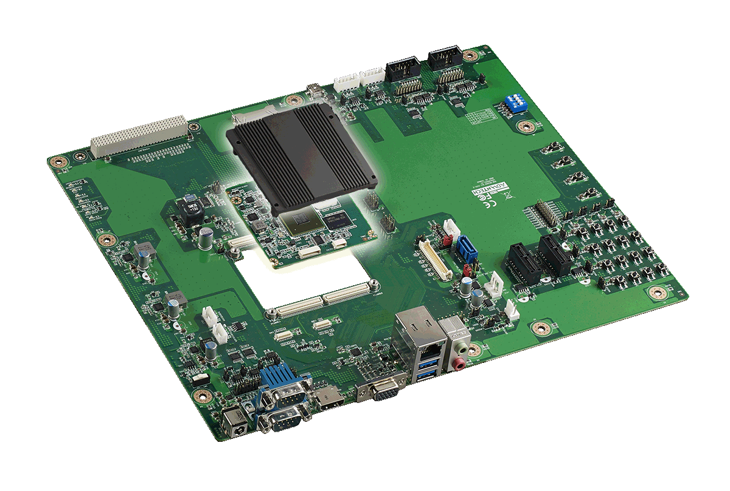
ROM-3420 is available now, along with the ROM-DB3900 evaluation carrier board for easy integration and design reference. Supplied schematics and layout checklists for carrier board development help you to develop your own carrier board more easily than before. Additionally, Linux BSP, test utilities, design utilities, and reference codes are ready for application development and device integration. Please contact your local salesperson or visit the website for more details. http://risc.advantech.com/

ROM-3420 RTX2.0 RISC COM module
- Freescale ARM® Cortex™-A9 i.MX6 Dual 1GHz high performance processor
- Onboard DDR3 1GB memory and 4GB flash capability
- Supports LVDS, parallel and HDMI with Full HD 1080p hardware video codec engine
- Supports 1 x PCIe, 1 x GbE, 1 x USB 2.0, 1 x USB OTG2.0, 1 x SATAII, 4 x I2C, 1 x I2S,1 x Camera in, 2 x CANbus, 10 x GPIO, and System Bus
- Supports wide range power input: 5V~24V
- Supports Linux V3.0.35 BSP
- Optional thermal solution

About Advantech
Founded in 1983, Advantech is a leader in providing trusted, innovative products, services, and solutions. Advantech offers comprehensive system integration, hardware, software, customer-centric design services, embedded systems, automation products, and global logistics support. We cooperate closely with our partners to help provide complete solutions for a wide array of applications across a diverse range of industries. Our mission is to enable an intelligent planet with Automation and Embedded Computing products and solutions that empower the development of smarter working and living. With Advantech, there is no limit to the applications and innovations our products make possible. (Corporate Website: www.advantech.com).

