New GigE Vision Firmware Release 1.3
GigE Vision cameras from IDS with extended functionality

With the new firmware release 1.3, IDS extends the functional range of its GigE Vision industrial camera models with a set of additional features. These include, for example, Auto Exposure, Auto Gain, Subsampling, Black Level, LUT or Gamma. In addition, new standard pixel formats are available as well as a simplified bandwidth management. This enables users to manage conveniently the available bandwidth in a multi-camera system.
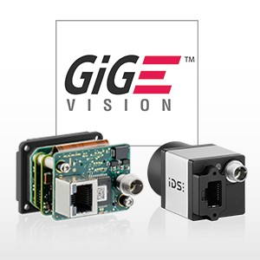
From now on all GigE Vision cameras from IDS are delivered with the new firmware. By means of the IDS’ update tool, users who already own GigE Vision cameras from IDS, can install and benefit from the extra functionality.

At the same time as the firmware release 1.3, many new GigE Vision industrial camera models are available. Both the compact uEye CP Rev. 2 family, as well as the versatile uEye SE and the robust uEye FA series are expanded by models equipped with the latest CMOS sensors from Sony, ON Semiconductor and e2v.

Characters including spaces: approx. 1,050

IMAGES (© IDS Imaging Development Systems GmbH):

New GigE Vision industrial camera models

ABOUT IDS
Imaging Development Systems (IDS) is one of the leading global manufacturers of digital industrial cameras with USB 2.0, USB 3.0, USB 3.1 Gen 1 or GigE interface. We serve the apparatus and mechanical engineering markets with comprehensive support and high-quality products that are “Made in Germany”.
As an owner-managed company, we have subsidiaries in Japan and USA as well as further offices in Europe and Asia. We focus on the company’s sustainable expansion, supported by our distribution partners in almost every country in Europe and Asia, and by 240 motivated and qualified employees worldwide.

PRESS CONTACT
IDS Imaging Development Systems GmbH
Oliver Senghaas
Product Communications/PR
Dimbacher Str. 6-8, D-74182 Obersulm, Germany
T: +49 7134 96196-0
F: +49 7134 96196-99
E: o.senghaas@ids-imaging.de
Web: www.ids-imaging.com

