STEGO Elektrotechnik GmbH, Schwaebisch Hall, April 23rd, 2019:

. P r e s s R e l e a s e No. 01_2019 .

Versatile Heater for Enclosures

Stego Flat Heater CP 061

Smaller in size, ever more powerful in output. Enclosures are increasingly equipped more densely with electrical and electronic components. Consequently, the space for necessary thermal measures is becoming tight. The Electronics Protectors from Stego know about the problem and counteract with resourceful solutions to avoid condensation.

Humidity in enclosures caused by temperature fluctuations, is a threat to sensitive electrical and electronic installations. Increasing the temperature in enclosures is the most effective countermeasure. The Flat Heater CP 061 is a solution, especially in densely equipped enclosures. Space-saving design was a top priority for Stego’s developers when designing the CP 061. Therefore, focusing on a flat design of the heater body was key. An extruded aluminium profile with a rectangular cross-section of 100 mm width by 8 mm height serves as raw material for the heater body. By varying the length of the heater body, users are given a choice between two heating capacities: 50 W (length 239 mm) and 100 W (length 414 mm). The CP 061 integrates well into enclosures and cabinets giving users the choice for the installation as a contact or convection heater. The heating element is a resistance heater.

Best practice for space-saving is the attachment to the cabinet or enclosure wall; with only 8 mm in height the ultra-flat heater fits in almost any gap. In addition to cabinet walls, even the door is a possible option when in need for a particularly space-saving location. The maximum surface temperature of the heater body reaches 150° C and thus ensures effective contact heating. A specially developed mounting system compensates for expansions of the heater body. As a result, the flexible suspension prevents the heater body from deforming, thus avoiding a cabinet wall from warping. Solid surface contact is required for effective heating. Operated as a convection heater, the CP 061 warms up ambient air within the installation space. The required space for the placement of the heater is minimal, even in this mode of use.

Borehole spacing of the Flat Heater was optimised for enclosure frame profiles with a pitch of 25 mm. The CP 061 is ready for connection with a strain relief by default. An integrated safety cut-out provides for protection against overheating in case of a malfunction. This safeguards the device against critical temperatures by switching off at a critical temperature. When cooled down, an automatic switchback sets the CP 061 operational again. A practical feature for continuous operation, which the Flat Heater CP 061 is designed for.
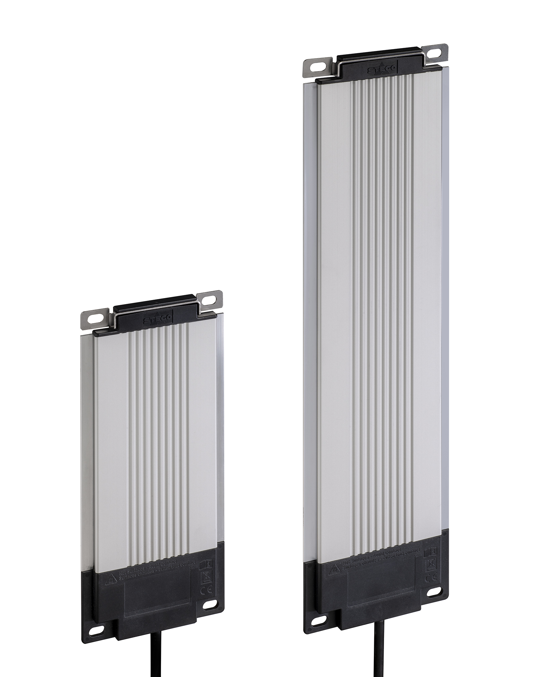
Stego Flat Heater CP 061, 50 W and 100 W heating capacity, contact and convection heater for enclosures.
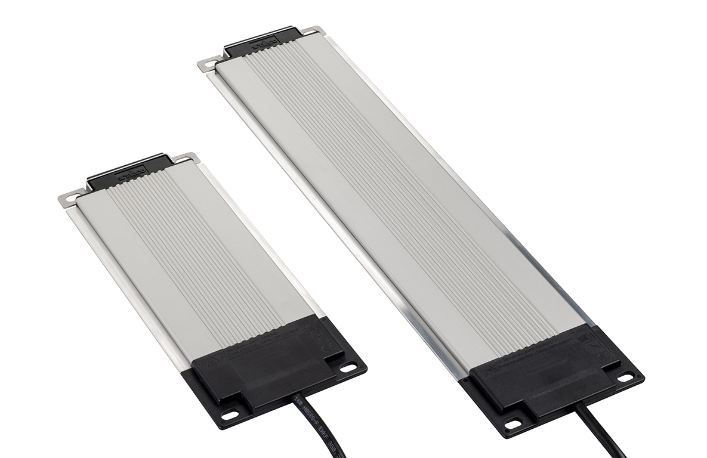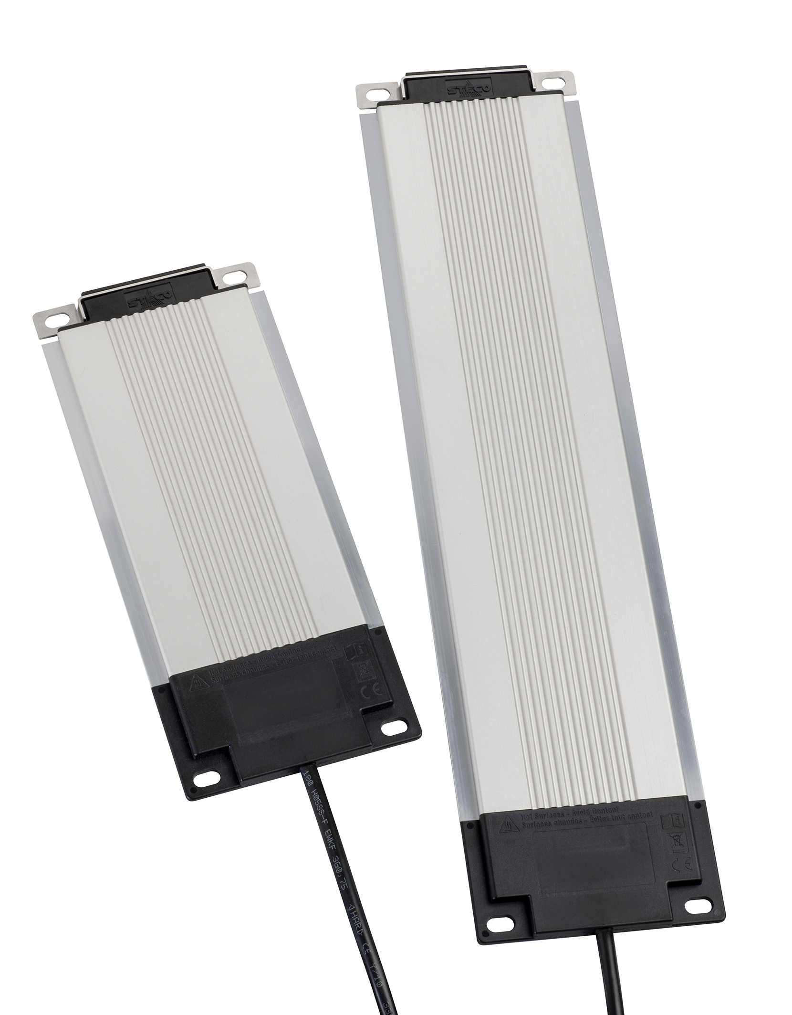

Stego Flat Heater CP 061, 50 W and 100 W heating capacity, contact and convection heater for enclosures.

STEGO - Perfect Thermal Management

Since it was founded in 1980, STEGO Elektrotechnik in Schwaebisch Hall, Germany, has been developing, producing and selling an ever-growing range of products for the protection of electric and electronic components. All STEGO products for cabinets and enclosures – heaters, fan heaters, filter fans, LED-lamps, thermostats, hygrostats and accessories - are aimed at reaching optimum climatic conditions in the most varied environments, ensuring that all sensitive components work reliably at all times. STEGO is now represented at 12 locations and by more than 200 sales partners worldwide.

www.stego.de

Press contact:

Siegfried Oerthel | soerthel@stego.de | Tel. +49 791 95058-181

STEGO Elektrotechnik GmbH
Kolpingstraße 21
74523 Schwaebisch Hall
Germany
Scan me for
STEGO NEWSROOM

