Press contact:  CONEC Elektronische Bauelemente GmbH Registered office:  Katja Schade  Phone: 02941/765-350  Fax: 02941/765-65 | Ostenfeldmark 16  D-59557 Lippstadt  www.conec.com

Press release 01.12/2017

Title: M12x1 Connectors field attachable, angled, 360° shielded, A-, B- und D-coded – Flexibility for applications with limited installation space
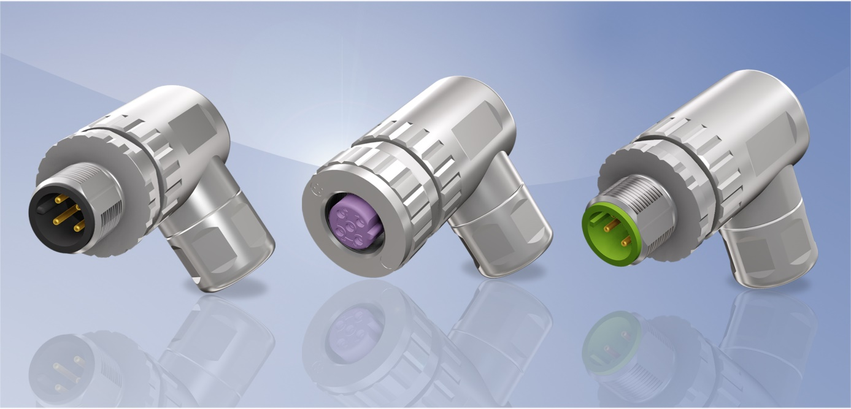
Caption: M12x1 Connectors field attachable, angled, 360° shielded, A-, B- und D-coded

M12 connectors are used in industry and transport for sensor/actuator cabling as well as for BUS systems. It is important to use reliable, flexible and robust components. Connectors that are easy to assemble play an important role in the implementation process.

The new angled field attachable M12 connector with screw termination offers the appropriate solution and is available as A-, B- and D-coded version. The very compact and lightweight design is ideally suited for applications with limited installation space.
The precision machined screw contacts can accommodate flexible wire cross-sections up to AWG 16 / 1.5 mm² and are therefore suitable for a wide range of common industrial data cables.

The advantage of the screw contacts is that there are no additional costs for special assembly tools and the contacts can be assembled several times.The screw contacts can be processed with standard screwdrivers.

The connector housing is completely made of metal and therefore fully shielded. The plugs are designed for cable diameters from 4.5 to 8.3 mm and the shield connection is made at 360° on the full circumference. A protective sleeve on the inside of the connector ensures optimum insulation of the connected wires to the connector housing.

All versions meet the IP67 degree of protection when plugged and screwed in.

The plastic mainly used in this connector series has been tested according to DIN EN 45545-2:2016-02 R24 and reaches the highest hazardous level 3 (LOI > 32 %).

The vibration and shock test has also been passed according to IEC 61373:2010-10 and thus this series meets the high demands of railway technology within the passenger cabin.

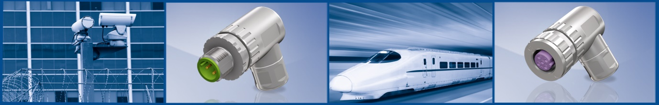

Benefits:
• Fast and safe installation in the field
• Compact and robust design
• Precision machined contacts
• 360° shielding
• Many different variants (A, B, D coding)
• IP67 degree of protection
• Suitable for a wide range of industrial cables
•No special tools required for assembly/connection

Fields of application:
• Transportation
• Automation technology
• Industrial Ethernet
• Control engineering
• Cable assembly
• Industrial interfaces
• Housing and device connection
• Medical
• Building automation
• Assembly and production lines
• Process automation
• Safety and monitoring systems
• Communication technology

Produktdetails:

Technical Data:

Specification | 4 pos. | 5 pos.
Coding | A, B, D | A, B
Female | ✓
Male | ✓
360° shielded | ✓
Design | angled
Termination | Screw termination
Wire cross section | up to 1.5 mm² / AWG 16 incl. wire-end sleeve
Accessories locator | ✓
Protection caps | ✓
Cable diameter | 4.5 mm to max. 8.3 mm
Degree of protection | IP67 (in plugged and screwed state)
Temperature range | -40 °C to +85 °C

