Press contact:  CONEC Elektronische Bauelemente GmbH Registered office:  Katja Schade  Phone: 02941/765-350  Fax: 02941/765-65 | Ostenfeldmark 16  D-59557 Lippstadt  www.conec.com

Press release 2.02/2019

Title: M8x1/M12x1 insulation bodies/socket housings SMT/THR A-, B-, D-, P-, X-coded
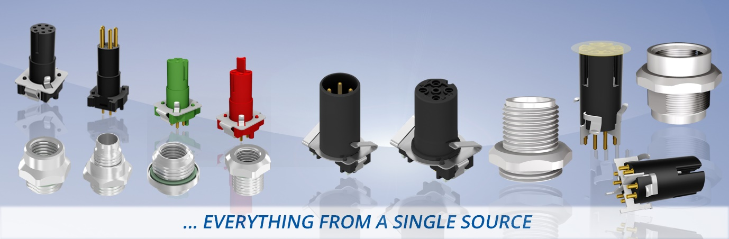
Caption: M8x1/M12x1 insulation bodies/socket housings SMT/THR A-, B-, D-, P-, X-coded

Compact connection solutions are required for maximum flexibility in device development.
CONEC therefore offers a comprehensive range of connectors of various sizes and contact layouts for automatic production processes.
The advantages of THR and SMT assembly are that the connection technology can be integrated into the SMT process and thus the efficiency in device production in the electronics sector can be increased. Production costs of the devices can be reduced by the use of fully automatic equippable connection elements. While SMT technology is suitable for applications exposed to medium electromechanical loads, products with THR connection are particularly suitable when higher forces can act on electromechanical PCB components.

CONEC's first M12x1 SMT connector family was introduced in 2012. In addition to A- and B-coded 4-, 5- and 8-pos. variants in shielded and unshielded versions male and female, the portfolio also includes the X-coded female variant for high-speed data transmission up to 10 GBit/s in the industrial enviroment.

The continuous miniaturization of electronic assemblies led to CONEC developing a more compact M8x1 connector series for SMT and THR assembly in 2015.
The A- and B-coding for signal transmission have now been supplemented by D-coding for industrial Ethernet transmission (100 Mbps) and P-coding for the EtherCAT P transmission protocol. Thus, it is now possible to implement fast data transmissions into small devices via IP67 protected interfaces.

Currently, the following sizes, codings and numbers of positions are available:

…EVERYTHING FROM A SINGLE SOURCE
 | Installation height | M8x1 |  |  |  |  |  |  |  |  |  | M12x1
Termination |  | SMT/THR |  |  |  |  |  |  |  |  |  | SMT |  |  |  |  |  | SMT/THR
No. of poles |  | 3-pos. |  | 4-pos. |  |  |  | 5-pos. |  | 8-pos. |  | 4-pos. |  | 5-pos. |  | 8-pos.
Coding |  | A |  | A |  | D | P | B |  | A |  | A |  |  |  |  |  | X
 |  | ST | KU | ST | KU | KU | KU | ST | KU | ST | KU | ST | KU | ST | KU | ST | KU | KU
Front panel  mounting | 9 mm | ✓ | ✓ | ✓ | ✓ | ✓ | ✓ | ✓ | ✓ | ✓ | ✓ | ✓ | ✓ | ✓ | ✓ | ✓ | ✓ | ✓
 | 13 mm | ✓ | ✓ | ✓ | ✓ | ✓ | ✓ | ✓ | ✓ | ✓ | ✓ |  | ✓ |  | ✓ |  | ✓ | ✓
Back panel mounting | 6 mm | ✓ | ✓ | ✓ | ✓ | ✓ | ✓ | ✓ | ✓ | ✓ | ✓ |  |  |  |  |  |  | ✓
 | 10 mm | ✓ | ✓ | ✓ | ✓ | ✓ | ✓ | ✓ | ✓ | ✓ | ✓ |  |  |  |  |  |  | ✓

ST= Male/KU= Female

The insulating bodies meet the special requirements of the market, because they are:

• Two-piece (insulation-body and flange housing without fixed mechanical connection)
• Modular in construction
• Available in both SMT and THR technology
• Suitable for both front and back panel mounting
• Available for different installation heights

This allows the user, for example, to mount the flange housing from the front or rear of his device. Subsequently, the board equipped with the insulation-body can be mounted from the inside (combined assembly). In addition, the connectors are ideal for integrative designs where the M8 thread is shaped to the customer housing. This creates maximum design freedom.

By default, the protection class in mounted condition is IP67, the degree of protection of the mating-face in unmated condition is IP20.
Fields of application:
• Drive technology
• Enclosure and device connection
• Rotary encoder manufacturer
• Sensors
Benefits:
• Compact design
• Flexibility in device connection
• Maximum design freedom
• Degree of protection IP67

Product details:

 | M8x1 |  |  |  |  |  | M12x1
No. of poles | 3-pos. | 4-pos. |  |  | 5-pos. | 8-pos. | 4-pos. | 5-pos. | 8-pos. | 8-pos.
Coding | A | A | D | P | B |  | A |  |  | X
Termination | SMT/THR |  |  |  |  |  | SMT |  |  | SMT/THR
Mounting style | Front panel mounting  & Back panel mounting |  |  |  |  |  | Front panel mounting
Rated voltage | 48V AC /60V DC |  |  |  | 30V AC / 30V DC |  | 250 V | 60 V | 30 V | 48 V
Current rating | 4 A @ 40°C |  |  |  |  |  | 4 A |  | 2 A | 0,5 A
Temperaturerange | -30°C ... +85°C |  |  |  |  |  | -25°C ... +95°C
Mating cycles | >=100 |  |  |  |  |  | >=100
Degree of protection | IP67/IP20 |  |  |  |  |  | IP67/IP20

