Press contact:  CONEC Elektronische Bauelemente GmbH Registered office:  Katja Schade  Phone: 02941/765-350  Fax: 02941/765-65 | Ostenfeldmark 16  D-59557 Lippstadt Germany  www.conec.com

Press release 1.02/2019

Title: CONEC B23 Hybrid connectors field attachable - available from now on!
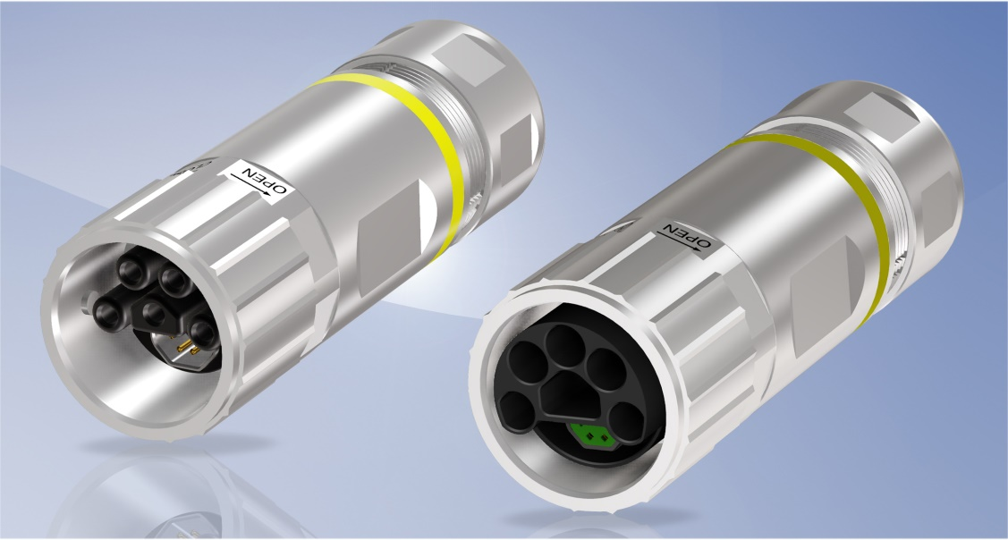
Caption: CONEC Hybrid B23 Connectors field attachable

With the newly developed CONEC hybrid connector series (B12, B17, B23, B40), a compact hybrid connector system has been developed which combines and transmits the power supply and data transfer to CAT5 via a specially developed hybrid cable. This single-cable technology corresponds to modern connection and interface wiring technology.

If it should be necessary to assemble a plug connection due to local conditions, size B23 is now also available as a field attachable variant with crimp connection. The existing product range, consisting of the overmoulded version and the matching receptacles, is supplemented by this.
The housing is a robust nickel-plated metal housing where cables and can be used with and without outer shield. Poka-Yoke makes the assembly of the connectors very easy and no special tools have to be used.

Like all other sizes, the field attachable CONEC B23 hybrid connector has a separately shielded 4-pos. data element for the transmission of Industrial Ethernet according to ISO11801 Class D or alternatively signals with currents up to 3 A. Wire cross-sections up to AWG22/0.34 mm² and strand diameters up to 1.6 mm can be easily assembled. The size is completed by a number of power contacts tailored to the respective applications.

A 5-pos. variant (4+PE) for a wire cross-section of 4 mm² is available as standard. A 6-pos. version (3+PE + 2) with 4 power contacts for 4 mm² wire cross-section each in conjunction with 2 power contacts for 2.5 mm² wire cross-section each is optionally available. This variant can be used, for example, for motors with electric brakes.
The connectors can be assembled with both shielded and unshielded hybrid cables. If cables with outer shield are used, the shield is applied 360° in order to achieve a maximum shielding effect. Cables with outer shield, exactly adapted to this connector and suitable for drag chain applications, are also available.

Locking is secured with a bayonet fastener, so that a time-consuming screw connection by means of a torque wrench is no longer necessary. A quarter turn ensures a secure connection and IP67 protection class. It is important to note that the bayonet can only be locked, if the hybrid connectors are completely mated in. The risk of failure due to incompletely mated or unscrewed connectors is thus greatly reduced.

Three different codings per mating face ensure that connectors that are unpluggable among each other can be used for different applications.

Product Details:

Fields of application:
• Drive technology
• Machine manufacturing
• Robotics
• Assembly and production lines
• Renewable energy sources

Benefits:
• Flexible and easy assembly in the field
• Space saving by transmitting data and power in one connector
• Reduced cable expenditure
• Cost saving
• Fast and secure connection by bayonet locking
• Protection class IP67
• Compact and robust design

Size | B23
Coding | 1,2,3
Design | axial
Number of data contacts | 4
Number of power contacts | 4+PE, 2 + 3+PE
Current rating  Data contacts | 4 A @ 40°C
Current rating  Power contacts | 30 A @ 40 °C  30 + 20 A @ 40° C
Rated voltage  Data contacts | 24 V DC
Rated voltage  Power contacts | 630 V AC / 850 V DC
Degree of protection | IP67

