Presse release 16SH15
EMO Aktuell August 2015
SHW Werkzeugmaschinen presents technical novelties and anniversary editions at the EMO
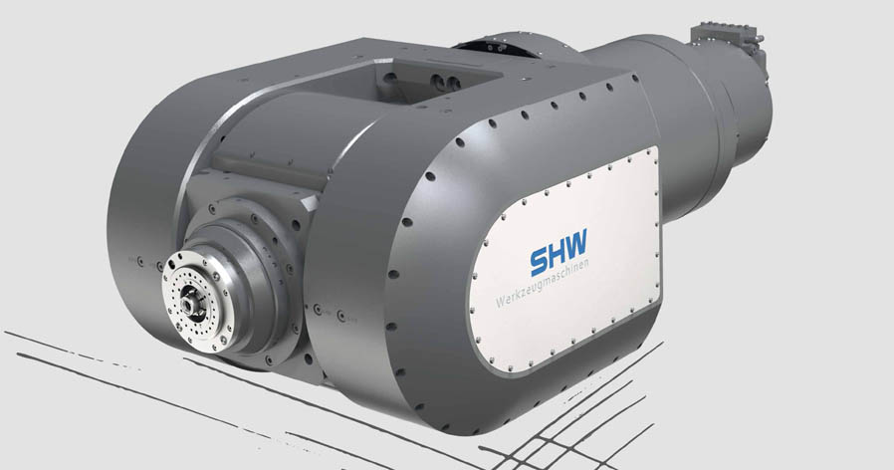
SHW Werkzeugmaschinen shows a spectacular array of novelties at the EMO
Contact and information:
SHW Werkzeugmaschinen GmbH
Danny Basic
Alte Schmiede 1
D-73433 Aalen-Wasseralfingen
Tel. +49 7361 – 5578 808
danny.basic[at]shw-wm.de
www.shw-wm.de
Text + images at www.pressearbeit.org

(Aalen) SHW Werkzeugmaschinen shows a truly spectacular array of novelties at the EMO. The technological highlight is the new SHW fork milling head with continuously variable A- and C-axis and high frequency spindle. Furthermore, the company presents a precision granite machine bed for the highest possible dimensional accuracy in difficult climate conditions and the new SHW TightBlock for a level machine installation without a foundation. The sensation for bargain hunters is the 650 years anniversary edition "eysenwerck" offered at a special rate.
05-10 October 2015
We will be there:
Hall 1, C13
According to SHW Werkzeugmaschinen, the new fork milling head, newly developed in cooperation with the Kessler company, is particularly interesting for 5-axis simultaneous machining in classical mechanical engineering as well as for smoothing in module-making. With up to 26,000 rpm, the integrated high frequency spindle is ideal for light metal machining. For steel machining, the user can choose between High-Feed-Cutting (HFC) or High-Speed-Cutting (HSC). The continuously variable A- and C-axis enables machining around the work piece. Traverse distan-ces of x = 2,000-30,000 mm, y = 1,300-2,600 mm and z = 1,300-1,500 mm offer the user tremendous freedom even for bulky pieces. Weights of work pieces of up to six tons are possible, because the milling head moves around the work piece. The new SHW-fork milling head is available in the two editions UniSpeed and PowerSpeed.

Granite bed for highest possible precision
The new precision granite bed by SHW promises highest precision and dimensional accuracy when working under unstable climate conditions. Due to the very low expansion coefficient and high abrasion resistance and rigidity, the highest possible precision is to be expected. The new machine bed made of massive granite is made as a block from one piece. Due to the thermal characteristics, the factory hall does not have to be air-conditioned. And still the user will achieve the most precise results.
The SHW-TightBlock is also new. A welded steel construction filled with polymer concrete in front of the machine enables level assembling of the PowerSpeed series without a foundation. Despite traversing distances of x > 3,000 mm and y > 1,600 mm and workspace which is completely freely configurable, SHW offers total enclosure of the machine and provides a high displacement circle when working with bulky work pieces.

Anniversary machine for bargain hunters
The big hit at the EMO will surely be the SHW-650-years anniversary machine "eysenwerck". SHW has extended its special offer from the in-house trade fair until 31 October 2015. For as long as stocks last, price-conscious bargain hunters will receive an unbeatable 134,000 Euro price advantage on the UniSpeed 5 standard machine. SHW at the EMO, Hall 1, stand C13.
361 words, 2.789 characters
For reprint please send two copies to SUXES
For text and images see also www.pressearbeit.org

((Company Info SHW Werkzeugmaschinen GmbH))

A young company with an ancient tradition
SHW Werkzeugmaschinen GmbH is one of the world's leading manufacturers of machine tools for the machining of large parts. The machining centres with large traverses are used for production of parts, which must have a high degree of precision in spite of their huge size, for machinery and mould making, turbine and tooling production and for the aircraft industry. What started as a young and innovative company in Aalen-Wasseralfingen in 1999, actually looks back on a tradition in industrial technology that dates back to 1365. Consistent growth and a commitment to the Swabian location, with some 200 highly qualified and quality-conscious employees, have recently led to an annual turnover of around 63 million Euros. A presence in 45 countries ensures customer proximity worldwide.

Image directory SHW Werkzeugmaschinen, EMO 2015
2 clicks to text and image at www.pressearbeit.org.
Image Nr. 16-01 SHW_Gabelfräskopf.jpg.
The new fork milling head by SHW Werkzeugmaschinen is ideal for 5-axis simultaneous machining in classical mechanical engineering as well as for smoothing in mould-making.

