|  |  |  |
| --- | --- | --- |
| Press contact:  **CONEC Elektronische Bauelemente GmbH Registered office:**  Katja Schade  Phone: 02941/765-350  Fax: 02941/765-65 | Ostenfeldmark 16  D-59557 Lippstadt  www.conec.com | Conec Logo |

Press release 1.07/2020

### Title: CONEC IP67 D-SUB series - perfect for use in harsh environments!

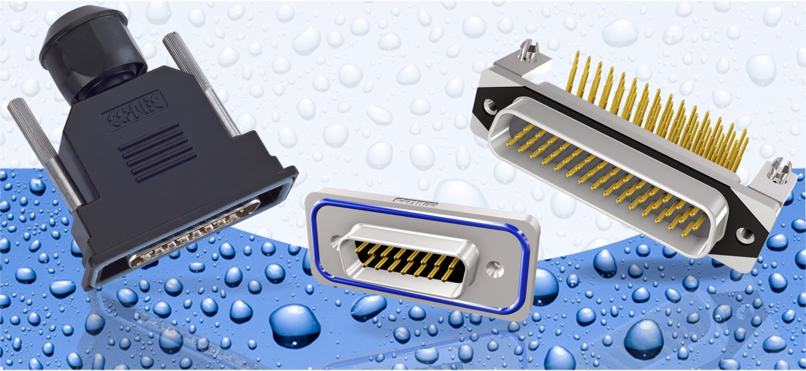

**Caption: IP67 D-SUB Serien Solid Body & CONEC SlimCon**

For industrial use in harsh environments, connector systems are needed that meet special requirements.

The CONEC range includes a wide variety of IP67 D-SUB connectors and corresponding protective hoods. In addition to the IP67 product series D-SUB, D-SUB High Density, Combination D-SUB, Combination D-SUB High Density and Filter D-SUB in standard design, CONEC offers the series

Solid Body and CONEC SlimCon. The advantage of the Solid-Body and CONEC SlimCon connector series is their one-piece zinc die-cast housing with nickel-plated surface, which guarantees optimum protection for the system.

The CONEC SlimCon series stands out not only due to its very small dimensions, but it also includes D-SUB filter connectors with an integrated low-pass filter for conducted interference protection. Thus, the interfaces to the interior of the device are not only perfectly protected against moisture, but can also contribute to meet EMC requirements.

The above connectors [Solid Body and CONEC SlimCon] are designed for rear panel mounting and come with a 4-40 UNC internal thread. Corresponding threaded bolts made of stainless steel are standard parts of the product series.

In addition to the connectors, various IP67 D-SUB protective hoods are also part of the CONEC product range. As a metallized version, IP67 hoods also provide protection against electromagnetic interferences.

Despite the compact design, the IP67 hoods have sufficient space to accommodate all D-SUB connectors as well as Combination D-SUB connectors with integrated coaxial or high current contacts. The mounting screws are made of stainless steel.

**IP67 CONEC SlimCon D-SUB, D-SUB High Density, Combination D-SUB**

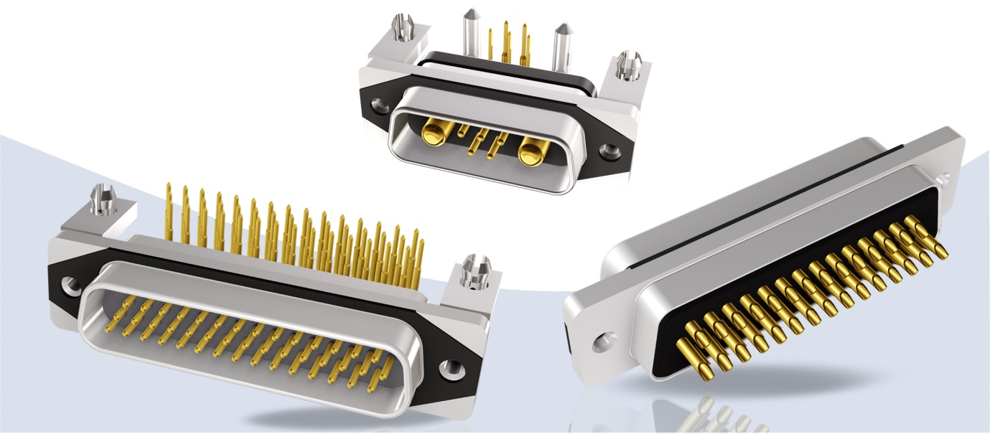

**Caption:** IP67 D-SUB Series CONEC Slimcon

The IP67 CONEC SlimCon connector series are available in housing sizes 1 to 3 as male and female. Due to their small size and one-piece zinc die-cast housing, they are ideally suited for industrial and harsh environments. Four contact surfaces ensure that the connectors are always mounted evenly with the existing seal on the device wall, thus preventing overstressing of the seal and at the same time ensuring safe assembly at the customer's site.

CONEC SlimCon connectors are designed for a panel thicknesses between 0.8 mm and 1.3 mm.

The size of the housing corresponds to the standard dimensions of the D-SUB connectors and achieves a reduction of the occupied area of 48% to 52% compared to the IP67 protected connectors with extended sealing frame. This generally applies to all CONEC SlimCon connectors.

|  |  |  |  |  |
| --- | --- | --- | --- | --- |
| Size | IP67 D-SUB  CONEC SlimCon | Standard  IP67 D-SUB | Reduction of the external dimensions compared to a standard IP67 connector | Reduction of the mounting surface |
| 1 | 30.88 mm x 12.8 mm | 39.4 mm x 21.1 mm | Width: 8.3 mm / 13,5 %  Height: 8.3 mm / 39 % | 52 % |
| 2 | 39.22 mm x 12.8 mm | 47.7 mm x 21.1 mm | 50 % |
| 3 | 53.1 mm x 12.8 mm | 61.4 mm x 21.1 mm | 48 % |

**IP67 CONEC SlimCon D-SUB Filter**

The IP67 CONEC SlimCon Filter series is sealed to the housing with a conductive EMC seal or optionally with a silicone seal. The housing sizes 1 to 3 are also available as male and female. Solder pin straight and solder cup contacts can be used. The integrated filters are offered with capacitance values of 370 pf, 820 pF and 1200 pF. Other capacitance values and special customer requirements can be created and offered on request.

CONEC SlimCon connectors are designed for a panel thickness between 0.8 mm and 1.3 mm.

**Productdetails Series CONEC SlimCon:**



**IP67 CONEC Solid Body D-SUB, D-SUB High Density, Combination D-SUB,**

**Combination D-SUB High Density**

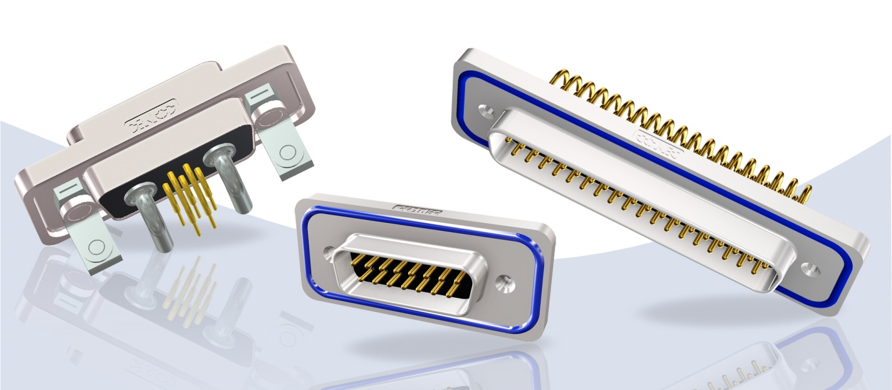

**Caption:** IP67 D-SUB Serie Solid Body

The IP67 CONEC Solid Body connector series are available in housing sizes 1 to 5 as male and female. Due to the one-piece zinc die-cast housing, this series is also ideally suited for industrial and harsh environments. For the IP67 D-SUB range, numerous versions are available in 09-pin to 50-pin and for the IP67 D-SUB HD applications in 15-pin to 78 pin. In the IP67 Combination D-SUB and Combination D-SUB HD range, too, a wide variety of connectors can be offered.

The CONEC Solid Body connectors are designed for panel thicknesses between 1.0 mm and 1.6 mm.

**Productdetails Serie Solid Body**



**IP67 D-SUB Hoods**

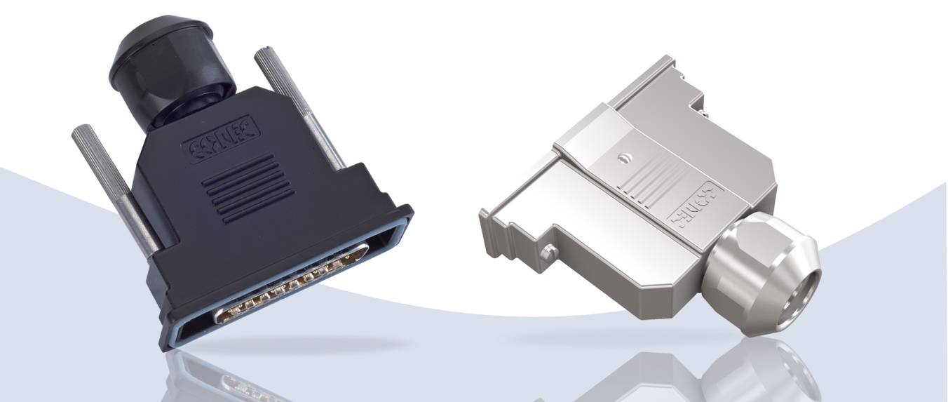

**Caption:** IP67 D-SUB Hoods

IP67 hoods are available in housing sizes 1 to 5 and can accommodate different cables with a diameter of 7 to 16 mm, depending on the size. The shielded and unshielded versions can be mounted quickly and easily. The compact design of the IP67 hoods offers a space-saving solution to protect sensitive interfaces.

**Productdetails IP67 D-SUB Hauben:**

|  |  |  |  |  |  |
| --- | --- | --- | --- | --- | --- |
|  | **D-SUB Hoods** | | | | |
| **Shell size** | 1 | 2 | 3 | 4 | 5 |
| **Cable diameter [mm]** | 7-9 | 9-11 | 12-12 | 14 - 16 | |
| **Can be used for** | D-SUB, D-SUB HD, Combination D-SUB, Combination D-SUB HD | | | | |
| **Mounting style** | ack screws 4-40 UNC / short screws 4-40 UNC | | | | |
| **Total height** | 54.30 – 77.20 mm | | | | |
| **Working voltage** | -30 °C up to +90 °C | | | | |
| **Degree of protection** | IP67 (in mated and mounted condition) | | | | |

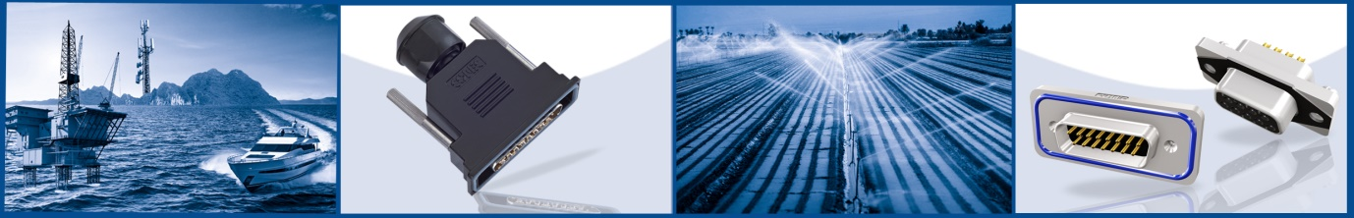

**Fields of application:**

|  |  |
| --- | --- |
| * Automation technology | * Transport industry |
| * Drive technology | * Testing and diagnostic equipment |
| * Cable assembly | * Process automation |
| * Housing and device connection | * Security and monitoring systems |
| * Industrial interfaces | * Control engineering |
| * Machine manufacturing | * Telecommunications |
| * Assembly and production lines | * Medical technology |
| * Power supply |  |

**Benefits:**

* One-piece zinc die-cast housing (Solid Body and CONEC SlimCon)
* Space-saving design (CONEC SlimCon)
* Low weight
* With integrated C filter (CONEC SlimCon Filter D-SUB)
* Fully shielded with EMC seal (CONEC SlimCon Filter D-SUB)
* Protection class IP67 (in mated and mounted condition, higher protection class on request)
* RoHS compliant
* Easy mounting