Press contact:  CONEC Elektronische Bauelemente GmbH Registered office:  Katja Schade  Phone: 02941/765-350  Fax: 02941/765-65 | Ostenfeldmark 16  D-59557 Lippstadt  www.conec.com

Press release 1.03/2020

Title: CONEC M12 Connectors with bayonet quick locking, convenient and reliable
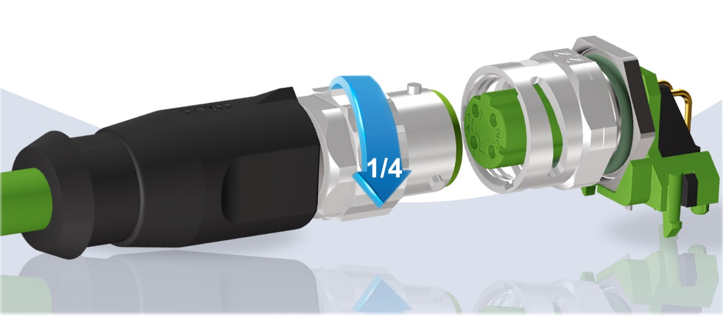
Caption: CONEC M12 Connectors with bayonet quick locking

The CONEC connector series with bayonet quick locking system allows safe and quick locking even in areas that are difficult to reach and/or not visible.

With the "three-point" bayonet locking it is possible to lock the connection by hand with a 90 ° turn. You get a direct tactile and acoustic feedback as soon as the connector is locked. The connectors are designed according to the draft standard IEC CD 61076-2-011/Ed1.
In order to meet the mechanical requirements with regard to tightness to dust and liquid media in industrial environments, no additional tools are required for the new M12 bayonet version by CONEC. When locked, the requirements of protection degrees IP65, IP67 and IP69K are met. In addition, the new series is shock and vibration resistant according to the railway requirements IEC 61373:2010, class 1B. The CONEC bayonet locking variant thus offers simplified handling and at the same time secure transmission of signals and data to the user.
The coupling sockets with solder pin termination are also equipped with an internal thread in the mating area, thus ensuring 100% backwards compatibility with standard M12 connectors. This means that new systems can be equipped with the M12 bayonet on the device side without any concerns.
The M12 bayonet series is presented as standard in the codings A and D. The PCB sockets are available in axial and angled form for back panel mounting and a panel thickness of 2.2 mm.

Fields of application:
- Automatiion technology
- Drive technology
- Housing and device production
- Maschine manufacturing
- Industrial interfaces
- Communications
- Security and surveillance systems
- Agricultural and construction machines
- Transport industry
Benefits:
- Tool-free, safe, fast and tactile three-point bayonet locking
- No mechanical connection between insulating body and socket housing
- 360° shielded
- Degree of protection (in mated condituion: IP65, IP67 und IP69K
- Shock and vibration resistant according to railway requirements IEC 61373:2010-10, class 1B
- RoHS compliant
- Various standardised installation height

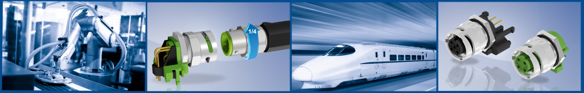

Productdetails:

Category | Connectors overmoulded |  | Sockets
No. of poles | 4-pos. | 5-pos. | 4-pos. | 5-pos.
Codierung | D | A | D | A
Gender | Male connector |  | Female connector
Configuration | axial 360 ° shielded |  | Print axial / angled shielded
Verriegelungsart | Bayonet |  | M12x1 & Bayonet
Rated voltage | 160 V | 60 V | 250 V | 60 V
Current rating | 4 A @ 40 °C | 4 A @ 40 °C | 4 A @ 40 °C | 4 A @ 40 °C
Cable | TPU, UL 4 x AWG22, green | TPU, UL 5 x AWG24 black
Mounting style |  |  | Back panel mounting, panel thickness 2.2 mm
contact plating | Gold über Nickel |  | Gold über Nickel
Degree of protection  (in mated condition) | IP65, IP67 und IP69K |  | IP65, IP67 und IP69K
Temperature range | -30 °C bis +70 °C | -30 °C bis +80 °C | -40 °C bis +85 °C

