Press contact:  CONEC Elektronische Bauelemente GmbH Registered office:  Katja Schade  Phone: 02941/765-350  Fax: 02941/765-65 | Ostenfeldmark 16  D-59557 Lippstadt  www.conec.com

Press release 1.09/2020

Title: DT and Superseal valve connectors with double cable outlet - ideal for use in DaisyChain applications
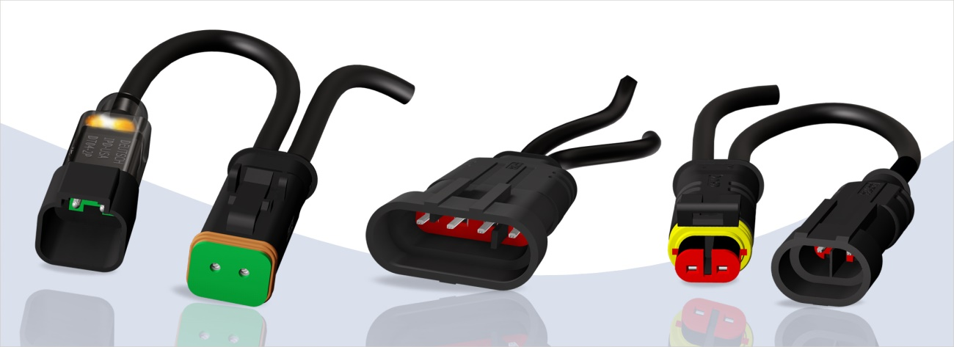
Caption: DT and Superseal valve connectors with double cable outlet.

CONEC has extended their range of DT and Superseal valve connectors by versions with double cable outlet.

Versions with double outlet are mostly used as Y-distributors for the distribution of signals and power, with variable cable lengths and the possibility to assemble different connectors at the cable ends according to customer requirements. Versions with double outlet are also often used in DaisyChain applications with multiple cascaded connectors, e.g. to control valves via a CAN-Bus.

The option of distributing the signals and power in the connector to two additional ones, offers possibilities for making systems more compact and thus for saving installation space.

The version with double outlet is offered with a PUR cable and a strand cross-section of 0.75 mm² in 1 m length.
The double outlet option is currently implemented for the 2-, 4- and 6-pos. DT (socket and plug contact version), as well as the 2- and 3- pos. socket contact version and the 3- and 4-pos. plug contact version Superseal.

In addition to the standard parts with open cable end, various combinations are possible upon request. Simple Y-connecting cables with connectors of the same type, as well as combinations with different connector types are possible.
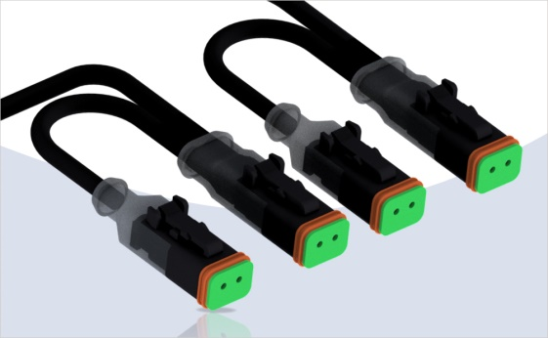
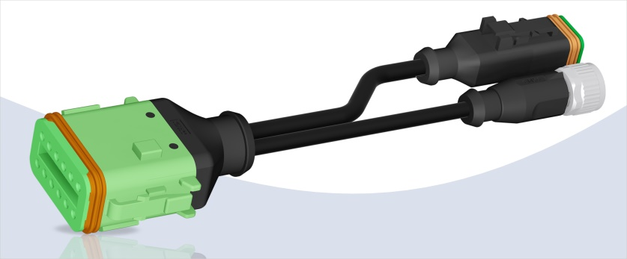
Caption: Cascaded valve connectors
Caption: Y-connecting cables

In addition to the versions with double outlet, CONEC has also implemented termination caps versions for the DT and Superseal series.

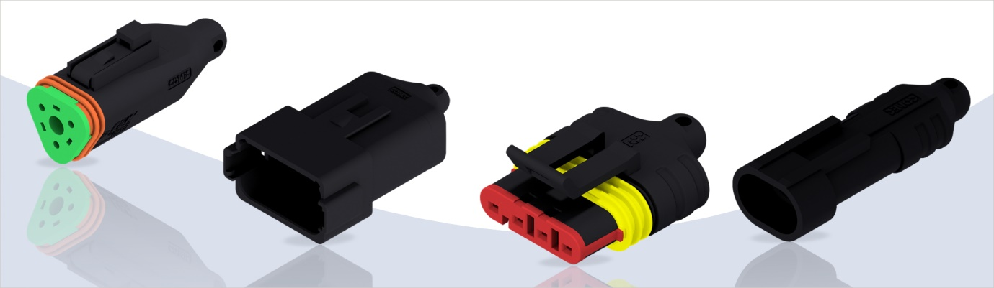
Bildtext: Y-Verbindungsleitung konfektioniert
Caption: DT- and VSS Superseal-Series protection caps

The termination caps not only protect unused connectors from contamination. When using these protective caps, the protection class according to IP67 / IP69K is also met.
The hole at the end of the caps also offers the possibility of attaching a rope to make the caps captive.
As standard, the caps are designed without contacts and additional circuit.

As an option, it is possible to integrate resistors and short-circuit bridges into the end caps. This way, for example, termination plugs for CAN-Bus systems and also connectors for coding can be realised. The application possibilities are very diverse.

Existing mounting options, which are plugged to the connector housing, can still be used for the double outlet and termination cap versions.

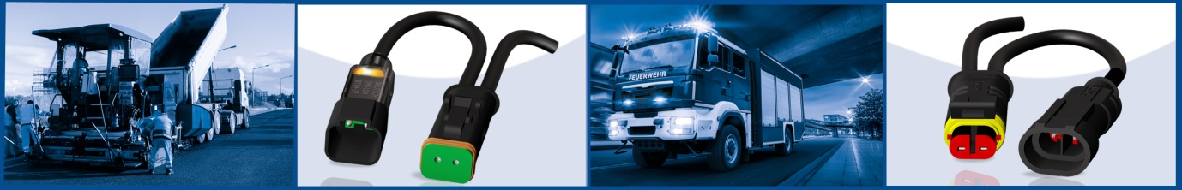

Fields of application:
- Agricultural & construction machinery
- Transport industry
- Road construction machinery
- Process control
- Control systems

Benefits:
- Compact design
- Distribution from one connector to 2 lines possible
- Optional use as cascade and Y-distributor saves connections and thus the required installation space
- Protection of unused connectors against contamination
- Can be used as a terminating plug
- Degree of protection IP67/IP69K
- Overmoulding ensures continuous protection from housing to cable.
- Use in harsh environments
- Use in bus systems
- Tamper-proof, tested assembly

Productdetails:

 | Superseal | DT
Rated voltage | Max. 24 V DC | Max. 48 V AC / 60 V DC
Current rating | 8 A at 40 °C [2-, 3-pole].  7 A at 40 °C [4-, 5-pin].  6 A at 40 °C [6-pin]. | 8 A at 40 °C [2-, 3-pole].  7 A at 40 °C [4-pin].  6 A at 40 °C [6-, 8-pin].  5 A at 40 °C [12-pin].
Degree of protection (in mated condition) | IP67 / IP69K
Terminal cross section | 0.75 mm² / AWG 18
Temperature range connectors | -40°C ... +85°C | -40°C ... +80°C
Temperature range cable | Fixed installation: -40°C ... +80°C  Flexible installation: -25°C ... +80°C
Housing | Superseal 1.5, black | Deutsch DT06/DT04

