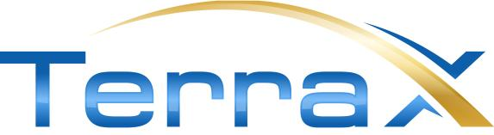

October 10, 2019
TSXV: TXR
Frankfurt: TX0
OTC Pink: TRXXF

News Release
Phase 2 Drilling At Sam Otto Delivers 25.5m of 1.26 g/t gold
Vancouver, B.C. – TerraX Minerals Inc. (TSX-V: TXR; Frankfurt: TX0; OTC Pink: TRXXF - https://www.youtube.com/watch?v=GmZpC44kBXY&t=7s ) is pleased to announce depth extension of gold mineralization at Sam Otto South with results from an additional 732 meters of drilling (2019 Phase 2) in three holes (Figure1). Phase 2 drill highlights from the Sam Otto South zone include: 25.5m of 1.26 g/t gold, including 10.0m of 1.76 g/t gold, demonstrating that the zone is thickening and also open at depth (Figure 2).The Sam Otto South area is open in all directions over a strike length of more than 2.5 km. See Table 1 below for a summary of 2019 Phase 2 Sam Otto South drill assay intervals.
Message from David Suda, President and CEO:
“Potential continues to grow at Sam Otto. Phase two drilling indicated that gold structures thicken at depth producing results that make this target exciting especially given its scale and proximity to top tier infrastructure. The results further verify the presence of a large mineralized system that remains open in all directions for expansion. The excellent width and grade at Sam Otto will be a primary focus of the next drill program and represents the best opportunity to add volume and ounces to our project. We look forward to our next drill program scheduled for this coming winter.”

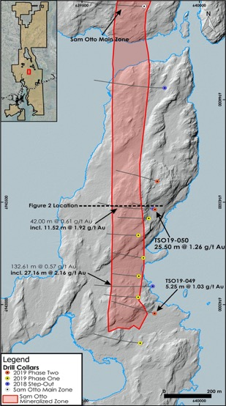
Figure 1: Surface trend of Sam Otto mineralization showing that the areas of 2019 Phase Two drilling confirms and extends the Sam Otto South mineralization at depth and along strike.

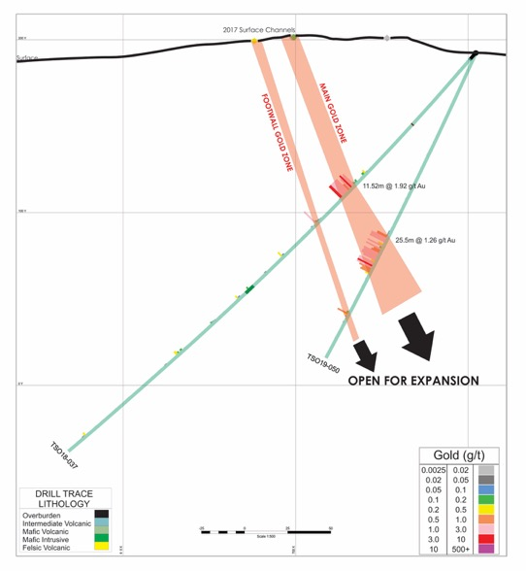
Figure 2: Cross Section of gold intersection for hole TSO19-050 drilled under winter 2018 drill hole TSO18-037, showing increasing thickness of mineralized zone.

Technical Summary:
Gold mineralization encountered within the Sam Otto South target is in shear zone structures 100 – 200 meters in width with strong sericite alteration and shearing. Gold mineralized zones contain disseminated sulphides. These geological characteristics are consistent with what is observed at the Sam Otto Main zone clearly demonstrating the bulk tonnage potential of the 4.5 kilometer Sam Otto South structure.

The twelve drill holes form the 2018 and 2019 campaigns in the Sam Otto South zone, together with surface channel samples, have shown that higher grade lenses (27.16 m of 2.16 g/t as example) are at a 10–15 degree angle to the main north–south trending shear and alteration zone. TerraX is planning step out drilling along the Sam Otto structure next winter when it will have 100% access along the 5+ km trend.

Table 1 – Sam Otto South:
Sam Otto South - Phase 2, 2019 DDH
Drill Hole | Dip | Azimuth | UTM Location |  |  | From (m) | To (m) | Interval (m) | Au g/t
 |  |  | Easting | Northing
TSO19-049 | -50 | 285 | 639808 | 6942958 |  | 135.50 | 152.75 | 17.25 | 0.44
 |  |  |  |  | incl. | 137.90 | 139.00 | 1.10 | 1.56
 |  |  |  |  | incl. | 147.50 | 152.75 | 5.25 | 1.03
 |  |  |  |  | and | 199.00 | 202.25 | 3.25 | 0.66
TSO19-050 | -65 | 284 | 639806 | 6943468 |  | 118.50 | 144.00 | 25.50 | 1.26
 |  |  |  |  | incl. | 120.00 | 123.00 | 3.00 | 2.01
 |  |  |  |  | incl. | 130.00 | 140.00 | 10.00 | 1.76
TSO19-051 | -45 | 285 | 639820 | 6943602 |  | 122.00 | 132.50 | 10.50 | 0.27
 |  |  |  |  | incl. | 128.00 | 131.00 | 3.00 | 0.72

Technical Appendix:
Holes were drilled normal to strike length and designed to cross mineralized structures a right-angles. Reported intersection widths are estimated to be 84-100% of true width.

For the 3 holes reported today, TerraX collected 557 samples for assay. Results ranged from below detection to 4.12 g/t Au. TerraX inserts certified standards and blanks into the sample stream as a check on laboratory QC. Drill core samples are cut by diamond saw at TerraX's core facilities in Yellowknife. A halved core sample is left in the core box. The other half core is sampled and transported by TerraX personnel in securely sealed bags to ALS Chemex's (ALS) preparation laboratory in Yellowknife. After sample preparation, samples are shipped to ALS's Vancouver facility for gold and ICP analysis. Gold assays of >3 g/t are re-assayed on a 30 gm split by fire assay with a gravimetric finish. ALS is a certified and accredited laboratory service. ALS routinely inserts certified gold standards, blanks and pulp duplicates, and results of all QC samples are reported.

The technical information contained in this news release has been approved by Joseph Campbell who is a Qualified Person as defined in "National Instrument 43-101, Standards of Disclosure for Mineral Projects.

About the Yellowknife City Gold Project

The Yellowknife City Gold ("YCG") project encompasses 783 sq km of contiguous land immediately north, south and east of the City of Yellowknife in the Northwest Territories. Through a series of acquisitions, TerraX controls one of the six major high-grade gold camps in Canada. Being within 10 km of the City of Yellowknife, the YCG is close to vital infrastructure, including all-season roads, air transportation, service providers, hydro-electric power and skilled tradespeople.

The YCG lies on the prolific Yellowknife greenstone belt, covering 70 km of strike length along the main mineralized break in the Yellowknife gold district, including the southern and northern extensions of the shear system that hosted the high-grade Con and Giant gold mines. The project area contains multiple shears that are the recognized hosts for gold deposits in the Yellowknife gold district, with innumerable gold showings and recent high-grade drill results that serve to indicate the project's potential as a world-class gold district.

For more information on the YCG project, please visit our web site at www.terraxminerals.com.

On behalf of the Board of Directors
"DAVID SUDA"
David Suda
President and CEO

For more information, please contact:

Samuel Vella
Manager of Corporate Communications
Phone: 604-689-1749
Toll-Free: 1-855-737-2684
svella@terraxminerals.com

In Europe:
Swiss Resource Capital AG – Jochen Staiger
www.resource-capital.ch – info@resource-capital.ch

Neither the TSX Venture Exchange nor its Regulation Services Provider (as that term is defined in the policies of the TSX Venture Exchange) accepts responsibility for the adequacy or accuracy of this release.
This news release contains forward-looking information, which involves known and unknown risks, uncertainties and other factors that may cause actual events to differ materially from current expectation. Important factors - including the availability of funds, the results of financing efforts, the completion of due diligence and the results of exploration activities - that could cause actual results to differ materially from the Company's expectations are disclosed in the Company's documents filed from time to time on SEDAR (see www.sedar.com). Readers are cautioned not to place undue reliance on these forward-looking statements, which speak only as of the date of this press release. The company disclaims any intention or obligation, except to the extent required by law, to update or revise any forward-looking statements, whether as a result of new information, events or otherwise.

