Press release 11WS18
automatica News June 2018
WEISS reduces complexity with its new Control Package
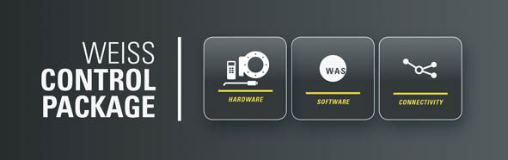
Smart set-up and operating software reduces complexity
(Buchen) At automatica, the automation specialist WEISS will be displaying its WEISS Control Package — an efficient package for its products that combines hardware and software elements to meet the needs of Industry 4.0. Thanks to the intuitive operating panel, setting up and controlling automation solutions does not require any specialist knowledge.
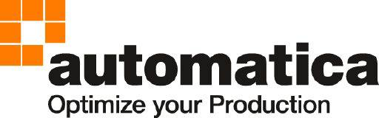

We’ll be there:
hall A5.302
Press contact:
WEISS GMBH
Kristin Andree
Marketing
Siemensstrasse 17
74722 Buchen, Germany
Tel. +49 6281 5208 6515
k.andree[at]weiss-gmbh.de
www.weiss-gmbh.de

“User friendliness was an important focus during development of the software,” explains Christian Göltl, Product Manager for Electronics and Controls at WEISS GmbH. At automatica, the automation specialist will be introducing the WEISS Control Package for setting up its products. The package includes perfectly fitting motor and encoder cables, finely tuned motor controllers and the latest version of WEISS Application Software, W.A.S. The software is based on an intuitive operating concept, and the interface is available both as a Windows program and as a web interface for mobile devices. The manufacturer’s automation solutions for the indexers, conveyor systems and handling units can be set up using W.A.S. with no expert knowledge needed.

Immediate start-up with no special knowledge needed
WEISS made a conscious effort to reduce complexity, so that the initial start-up is simple and easy without any special knowledge or information relevant to the application. No detailed knowledge is required for the drive hardware or for programming the positioning programs. Key parameters, such as mechanical data and control settings are preconfigured so that the program is ready for use.
WEISS products are freely programmable via the operating software, and the different modules within a production system so they can communicate with one another directly rather than via an intermediary or higher-level control system. Application-specific diagnostic functions interpret system errors and generate easy-to-understand warnings informing the user what practical steps they should take for corrective action.

Ready for Industry 4.0 applications
W.A.S. also meets the requirements for Industry 4.0 applications. Permanent current monitoring (PCM) enables continuous status monitoring as a basis for predictive maintenance. The program continually delivers measured values and status information for every axis. The auto-tuning function makes it simple to change the loading or position — the software autonomously redefines the optimal parameters and adapts the motor controllers accordingly. An integrated interoperable OPC UA interface means that W.A.S. acts as an IoT gateway and can transfer functionalities directly into the digital world.
374 words, 2,608 characters
When printing, please send two sample copies to SUXES
Text and images also at www.pressearbeit.org

((Company information — WEISS GMBH))

Making waves with innovative technology
WEISS GmbH was founded in 1967 and develops, produces and markets innovative automation solutions worldwide. Based on its core competency in the production of rotary indexing tables, the company develops standardized and customized automation solutions for customers in key sectors such as the automotive industry, machinery and plant engineering, the medical and pharmaceutical industry and the food and packaging industries. Branches in the USA, China, England and Switzerland, alongside a range of other agencies, secure WEISS a global presence. With around 450 employees, including 320 in Buchen, WEISS achieved consolidated turnover of around 100 million euros in 2017.

List of images WEISS GmbH, automatica 2018
Access text and image with just 2 clicks at www.pressearbeit.org.
Image no. 11-01 WS_.jpg.
At automatica, the automation specialist WEISS will be displaying its WEISS Control Package — an efficient set-up package for its products that combines hardware and software elements to meet the needs of Industry 4.0.

