Press contact:  CONEC Elektronische Bauelemente GmbH Registered office:  Katja Schade  Phone: 02941/765-350  Fax: 02941/765-65 | Ostenfeldmark 16  D-59557 Lippstadt  www.conec.com

Press release 1.10/2020

Title: RJ45 Industrial Ethernet Patch cord AWG22 & Patch cord with coloured overmould (AWG26)
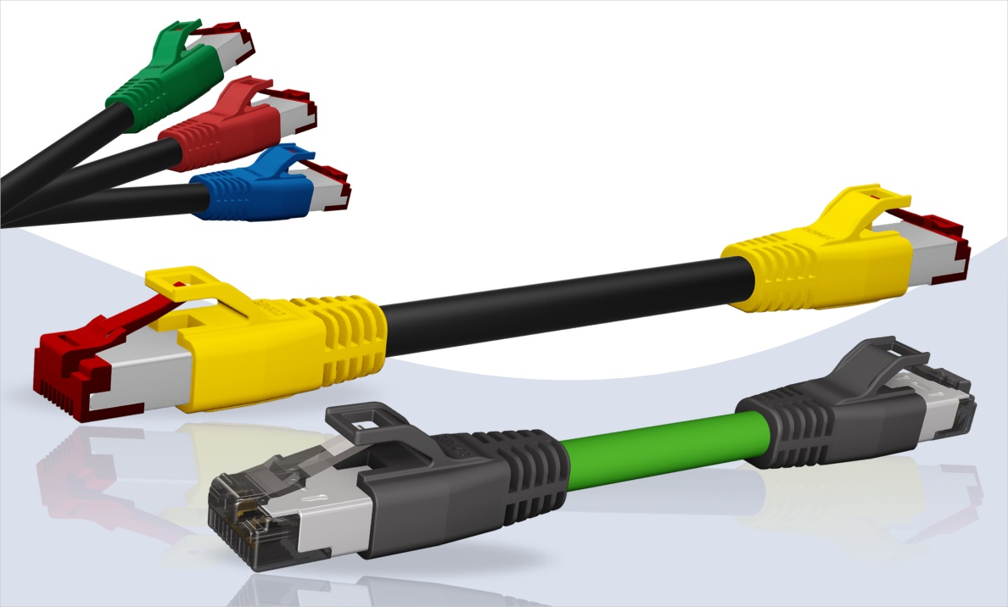
Caption: RJ45 Industrial Ethernet Patch cord

To round off the range of ready-made BUS cables, CONEC has included patch cords in its product range that are manufactured with an industrial Ethernet cord with a stranded wire cross-section of AWG22. This allows long transmission distances to be realised with low losses. In addition, the ProfiNEt cord with PUR insulation is suitable for use in industrial environments. The use of other cables will be tested on request. At all RJ45 connectors the cable shield is connected through the internal strain relief to the connector housing to ensure a continuous shielding.
PUR overmould of RJ45 offers kink protection and additional strain relief for the cord.

An integrated protection at the overmould prevent a damage of the RJ45 locking, when the cord will accidentally is pulled through obstacles.
A combination as a patch cord like e. g.RJ45 to M12 D-coded is available on request.

In addition, CONEC also offers patch cords with colour-coated RJ45. Thus, in a complex wiring environment, a patch cord can be quickly assigned to its port via the colour. CONEC offers coloured overmould upon request for almost all overmoulded RJ45s.

Fields of application:
- Automation technology
- Industrial interfaces
- Communication technology
- Machine manufacturing
- Control engineering
- Telecommunications
- Wireless controller

Benefits:
- Cat 5e overmoulded version
- Large strand cross-section AWG22
- Different colours for easy differentiation and assignment of different connections

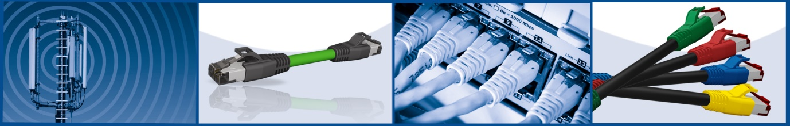

Productdetails:

Characteristics | RJ45 patch cord AWG 22
Connector | RJ45 Cat 5e
Shielding | ✔
No. of poles | 4
Cable | 4-pos. with filler  2 x 2 x AWG22  Ø up to 7,4 mm
Strain relief | TPU overmoulded black
Configuration  4-pos. | Pin 1  Pin 2  Pin 3  Pin 6  Shield | yellow  orange  white  blue  ----- | Pin 1  Pin 2  Pin 3  Pin 6  Shield
Degree of protection |  | IP20

Merkmale | RJ45 patch cord with coloured overmould
Connector | RJ45 Cat 5e
Shielding | ✔
No. of poles | 8
Leitung/ | 8-pos. Twisted Pair  4 x 2 x AWG26  Ø up to 7,4 mm
Strain relief | TPU injected
Configuration  8-pos. according to TIA | Pin 1  Pin 2  Pin 3  Pin 4  Pin 5  Pin 6  Pin 7  Pin 8  Shield | white, orange  orange  white, green  blue  white, blue  green  white, brown  brown  -------- | Pin 1  Pin 2  Pin 3  Pin 4  Pin 5  Pin 6  Pin 7  Pin 8  Shield
Degree of protection | IP20

