Press contact:  CONEC Elektronische Bauelemente GmbH Registered office:  Katja Schade  Phone: 02941/765-350  Fax: 02941/765-65 | Ostenfeldmark 16  D-59557 Lippstadt Germany  www.conec.com

Press release 1.10/2019

Title: CONEC Connector series IP67 RJ45 + IP67 USB 2.0 Dualport – Real-time data transmission and optimal protection in harsh environments.
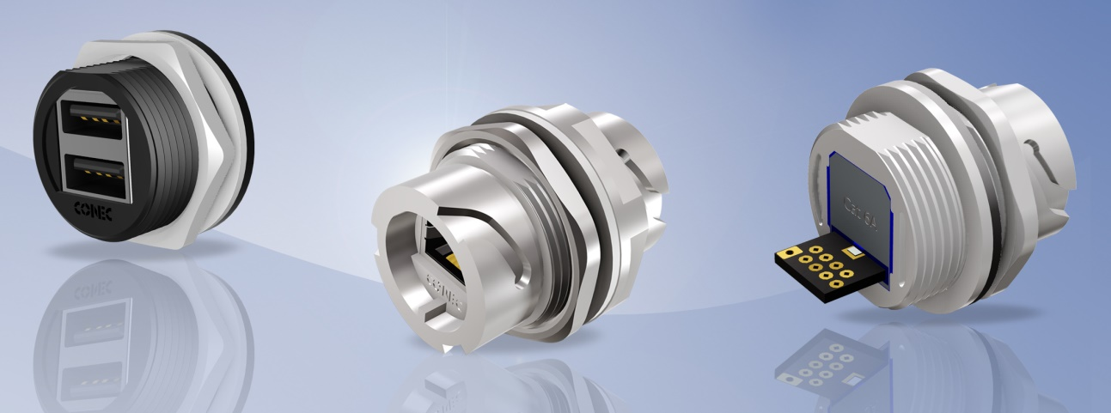
Caption: IP67 RJ45 Cat 6A & IP67 USB 2.0 Dual Port

Modern industrial applications place high demands on the connectors used to implement IP67 protected interfaces. On the one hand, it is necessary to transfer large amounts of data within a very short time E. g. in measuring systems which carry out dimensional checks and evaluations in production plants during the running process. Here the components are captured via camera systems and the images are transmitted to a computing unit, evaluated in real time, documented and the result sent back to the system in the form of a Go-NoGo decision. On the other hand, the climatic conditions under which connectors must operate smoothly are very demanding: extreme heat, fine sand on the edge of desert regions, extreme sub-zero temperatures in mountains and humidity in industrial environments.

IP67 RJ45 connectors from CONEC are suitable, for example, for outdoor use in network technology and telecommunications.

The CONEC connector series IP67 RJ45 with bayonet locking is now completely available with Cat 6A performance.
Cat 6A enables data rates up to 10 Gbit / s.

In addition to the field-attachable cable connectors and the inline adapters, the modules with PCB for connecting free cables with Cat 6A are now also available.

The IP67 RJ45 Cat 6A connectors with solder termination are available with plastic and zinc die-cast housings, the corresponding IP67 RJ45 Cat 6A Inline adapters with bayonet coupling on both sides with plastic housings. Both versions are designed for front or rear wall mounting with a maximum housing wall thickness of 3. 2 mm.

Additional protective caps are available to protect the plug against dirt and moisture when unplugged.

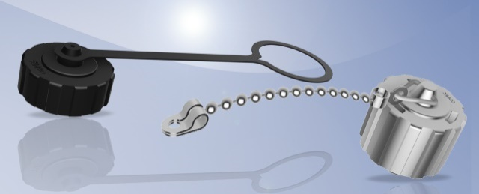

All Cat 6A products are fully backwards compatible to products with Cat 5e.

Furthermore, a panel mount connector (female) with USB 2.0 dual port in the same housing size as the IP67 RJ45 connector with bayonet locking was implemented.

The USB interface is used for local storage of data and system updates. The interface is protected against external influences in the unplugged state by an M28 protective cap.

IP67 USB2.0 dual port female connectors are available in plastic and designed for rear panel mounting with a maximum panel thickness of 3.2 mm.

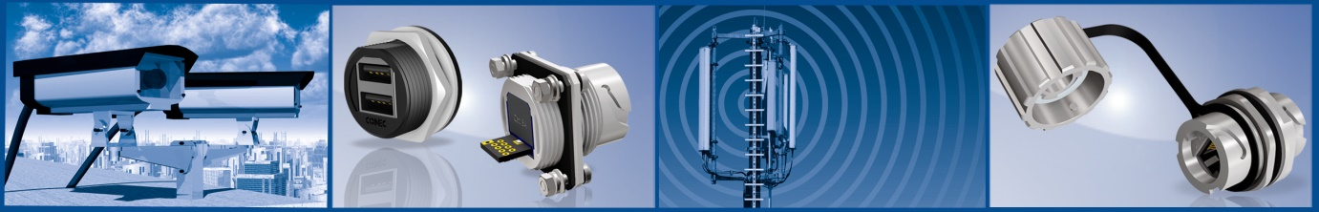

Produktdetails:
Fields of application:
• Automation
• Assembly and production lines
• Building automation
• Communications
• Housing and device connection
• GPS Navigation
• Industrial interfaces
• Cable assembly
• External hard drives in harsh environments
• Medical technology
• Process automation
• Security - and monitoring systems
• Telecommunications
Benefits:
• Compact design
• Quick assembly in the field
• Transmission rate up to 10 Gigabit with RJ45 Cat 6A
• Protection class IP67
• RoHS compliant
• Including protective caps
• Easy assembly

