Press contact:  CONEC Elektronische Bauelemente GmbH Registered office:  Katja Schade  Phone: 02941/765-350  Fax: 02941/765-65 | Ostenfeldmark 16  D-59557 Lippstadt  www.conec.com

Press release 1.02/2019

Title: M12x1 connectors overmoulded with colored plastic coupling elements simplify the assignment of complex cabling for applications in municipal technology and in the agricultural
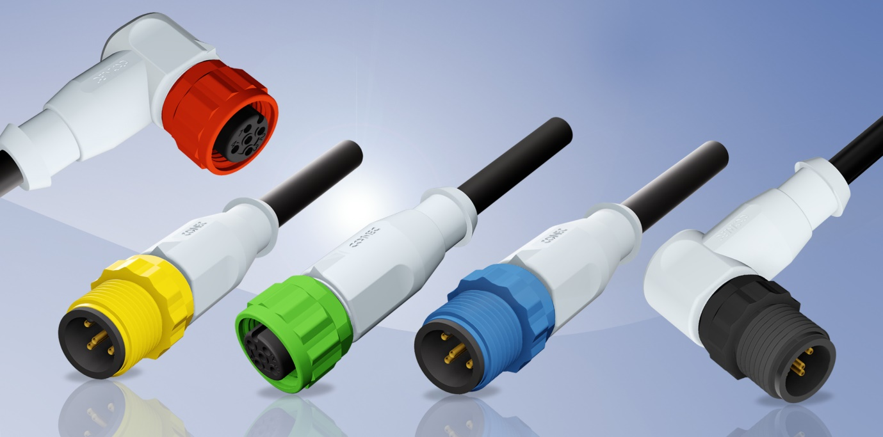
Caption: CONEC M12x1 Connectors overmoulded with colored plastic coupling screw/nut, terminal cross section up to 0,75 mm²

CONEC has expanded its product portfolio of overmolded M12x1 connectors, especially for municipal technology and the agricultural sector, to include variants with colored plastic coupling elements.

The possibility to choose between 5 colour variants (black, white, yellow, red, blue, green) simplifies the assignment of complex cabling and with a terminal cross-section up to 0. 75 mm², there are many possible applications. The plastic material used is resistant to weak acids, bases, alkalis and alkaline cleaning agents and is therefore perfect for applications where the chemical environment does not permit the use of zinc die-cast screw connections.

Typical examples of applications are dosing pumps for the treatment of drinking water, waste water and process water, dosing systems and disinfection systems for industrial use as well as applications in the agricultural sector.
Fields of application:
• Chemical industry
• Agricultural and construction machines
• Food industry
• Municipal industry
Benefits:
• Good grip of the screw elements
• Good chemical resistance of the connector
• Degree of protection: IP67

Product details:

 |  | M12x1
No. of poles | 4-pos. | 5-pos.
Rated voltage | 250 V | 60 V
Current rating | 4 A | 4 A
Coding |  | A
Terminal cross section | 0,75 mm² | 0,75 mm²
Degree of protection |  | IP67
Ambient temperature |  | -20°C bis + 85°C

