Press contact:  CONEC Elektronische Bauelemente GmbH Registered office:  Katja Schade  Phone: 02941/765-350  Fax: 02941/765-65 | Ostenfeldmark 16  D-59557 Lippstadt Germany  www.conec.com

Press release 1.05/2019

Title: M12x1 PCB sockets two-part, angled, insulation body with O-ring - for maximum design flexibility
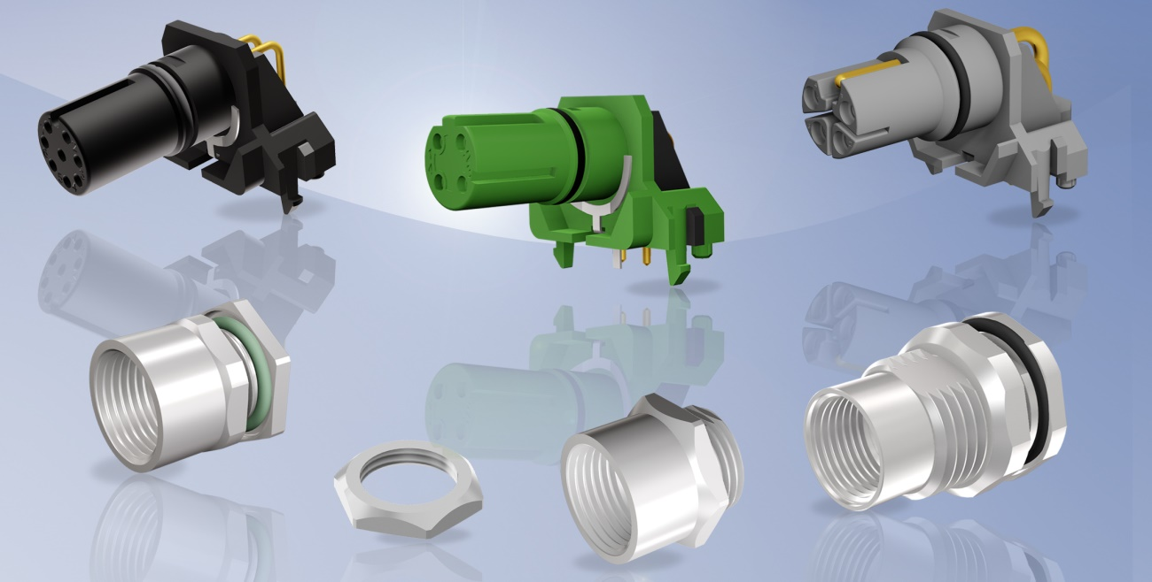
Caption: M12x1 insulation body A-, D-, L-coded with O-ring plus housing components

Today's modern device connection technology has to meet a wide range of requirements. Not only the miniaturization in engine and mechanical engineering plays a role, but also the increased power requirement for the supply of field devices in automation technology. Even in harsh environmental conditions, secure data transmission must be guaranteed.

CONEC expands its range for connections to the device by M12x1 two-part sockets with an O-ring integrated on the insulation body.

Due to the O-ring, the socket connectors are sealed against moisture from outside, even when unplugged. The two-part circuit board sockets are available with A-coding 4-, 5-, 8- and 12-pos. as well as D-coded 4-pos. for front and back panel mounting. The L-coded version is available for back panel mounting with 4- and 4+FE pos.

The user can mount the board equipped with the insulating body in various socket geometries. The CONEC sockets are suitable for combined mounting and are ideal for a design where the M12x1 thread of the socket is directly formed. This creates maximum design flexibility.

The insulation body fitted with angled contacts is snapped into the circuit board and then processed in a wave solder bath or by selective soldering. The connector housing is screwed into the device and the circuit board with the contact insert is mounted to it. The spring-loaded shield plate contacts the connector housing and ensures the shield connection.

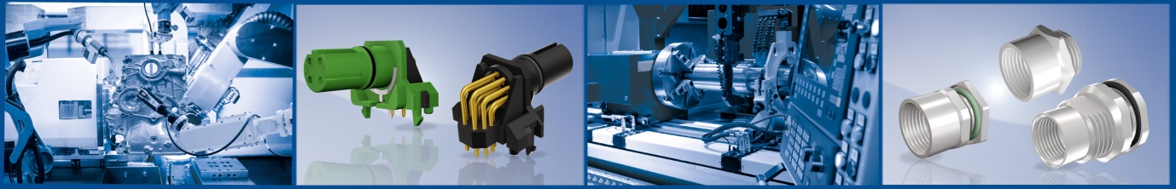

In the installed state and locked with the counterpart, protection class IP67 is achieved. The connectors are suitable for housing wall thicknesses of 2-3 mm and for PCB thicknesses of 1.6 mm.
The angled connector design makes it possible to position the PCB horizontally in the device, which in turn facilitates the assembly.

The innovative M12x1 sockets meet the special requirements of the market because of the following properties:

• Two-part (separation of insulating body with socket housing)
• Modular assembly
• O-ring on insulating body
• Suitable for front and back panel mounting (L-coding only back panel mounting)
• Suitable for fast data transmission (M12x1 D coding)
• For high current load capacity up to 16 A (M12x1 L-coding)

Fields of application:
- Automation technology
- Building automation
- Communication
- Industrial interfaces
Benefits:
- Large tolerance compensation between board and socket
- Suitable for various socket geometries
- Low load forces for the circuit board
- Low contact resistances of the shielding
- May also be used without CONEC socket housing

Technical data:

No. of poles | 4-pos. | 5-pos. | 8-pos. | 12-pos. | 4-pos. | 4 + FE
Coding | A, D | A | A | A | L | L
Type of termination | print
Mounting style | Front and back panel mounting |  |  |  | Back panel mounting
Rated voltage | 250 V | 60 V | 30 V | 30 V | 63 V
Current rating | 4 A @ 40°C | 4 A @ 40°C | 1.5 A @ 40°C | 1 A @ 40°C | 16 A @ 40°C
Temperature range | -25°C ... +85°C
Mating cycles | >= 100
Degree of protection | IP67

