Press contact:  CONEC Elektronische Bauelemente GmbH Registered office:  Katja Schade  Phone: 02941/765-350  Fax: 02941/765-65 | Ostenfeldmark 16  D-59557 Lippstadt Germany  www.conec.com

Press release 1.08/2019

Title: Power also for miniaturized interfaces – Series M12x1 L-coding
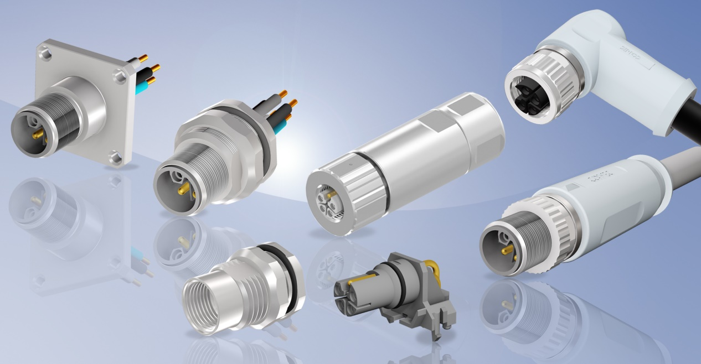
Caption: Product series M12x1 L-coding

CONEC has expanded its portfolio of M12 connectors to include L-coded variants, thus offering a compact, high-performance solution for automation devices. In addition to signals and data, more and more power has to be transmitted. Miniaturization in automation means that field devices and controllers are becoming ever smaller.

The overmoulded M12 L-coded connectors require 30% less installation space compared to a 7/8" connector. Due to the high current carrying capacity of 16 A with a strand cross-section of 2.5 mm², they are also able to ensure the power supply of devices via a miniaturised interface.

This is essential because the electrical drive technology devices are also becoming more and more compact. Thus, signals, data and power can now be transmitted continuously using the M12x1 connector system.

The new M12x1 L coding is standardized according to IEC 61076-2-111.

Connectors overmoulded:

The finished overmoulded connecting cables are ready for installation and optimally protected against environmental influences and manipulation by the resistant TPU overmould.
The required installation space for these axial or angled versions is also kept to a minimum. The cables have a TPU cable sheath as standard, whereby other cable qualities are optionally available.

Sockets:

The socket connectors for device mounting are available in different versions. Socket connectors are available for both front and rear panel mounting. If required, key surfaces provide anti twist protection in the housing.

Axial sockets with stranded wire connection in male and female design are currently available. In addition, angled PCB sockets in female design for direct PCB mounting are available.

Connectors field attachable:
Axial female and male variants are available for the connectors that can be assembled; these are designed with a screw connection for a strand cross-section of up to 2.5 mm².

The advantage of the screw contacts is that they can be assembled very easily and several times.
The maximum connection cross section of 2.5 mm² and the very compact design (outer diameter 23 mm only) make it possible to transmit maximum power with this connector system.

The plastic which is mainly used in this connector series has been tested according to DIN EN 45545-2:2016 R24 and thus reaches the highest hazardous level 3 (LOI > 32%).

All variants meet the IP67 protection class in mated condition.

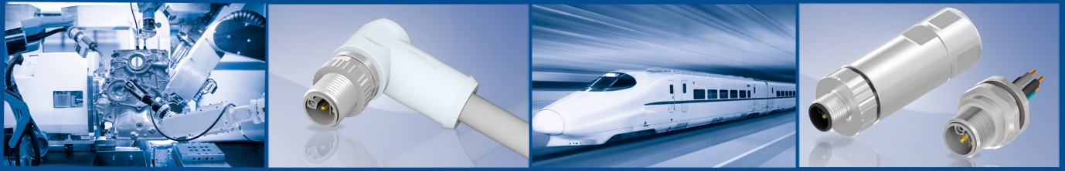

Benefits:
- Compact design
- IEC 61076-2-111 standard compliant
- High current transmission
- Protection class IP67
- RoHS compliant
- Anti-vibration
- Easy assembly

Fields of application:
- Drive technology
- Automation engineering
- Industrial interfaces
- Assembly and production lines
- Cable assembly
- Process automation
- Servomotors
- Mechanical manufacturing

