STEGO Elektrotechnik GmbH, Schwaebisch Hall, October 9th, 2018:

. P r e s s R e l e a s e No. 04_2018 .

S H O R T V E R S I O N (1.022 characters) )

More Light and Variability
Stego introduces the new LED Varioline, the most effective LED enclosure lamp within the Stego product range so far. Available in two versions with sizes from 400 to 700 mm, it illuminates even large control cabinets homogenous with over 1,000 / 1,700 Lm. Its translucent and thus glare-free rotatable light tube is equipped with bright mid-power LEDs. Specially selected LEDs provide for a long service life of 60,000 hours, which make the Varioline virtually maintenance-free. The Varioline emits tried-and-tested 6,500 K coloured daylight, so users benefit from natural vision conditions and confusion-free colour rendition.

The Varioline LED 121/122 versions offer an integrated socket for numerous European and international plug types, such as e.g. the US and Australia. Available switching options are: on-off switch, motion detector or connection for an external door contact switch. Screw or magnet fixing are the mounting options and allow for flexible and vibration-proof installation.

L O N G V E R S I O N (2.001 characters) .

Varioline Enclosure Lamp: More Light and Variability
Stego introduces the new LED Varioline, the most effective LED enclosure lamp within the Stego product range so far. Its powerful and homogeneous lighting ensure natural vision and confusion-free color reproduction which are key to user safety in enclosures. Versions with an optional integrated socket provide for additional application options.

The Varioline LED enclosure lamp from Stego combines bright lighting with compact dimensions. Available in two versions with sizes from 400 to 700 mm, it provides more than 1,000 Lm / 1,700 Lm at a moderate power consumption of 11 W / 16 W. Even large control cabinets are thoroughly illuminated in their depth and height. Its translucent and thus glare-free rotatable light tube is equipped with bright mid-power LEDs. With a beam angle of 120° these enable homogeneous illumination within control cabinets and enclosures. Specially selected LEDs provide for a long service life of 60,000 hours, which make the Varioline virtually maintenance-free. The Varioline emits tried-and-tested 6,500 K coloured daylight, so users benefit from natural vision conditions and confusion-free colour rendition.

All of the Varioline’s variability comes into play, when in addition to excellent lighting extra electrical devices need to be operated. For example, the Varioline LED 121/122 offers an integrated socket for the power connection of laptops or diagnostic devices. Numerous European and international plug types, such as e.g. the US and Australia, are available.
The LED Varioline also features versatile switching options. On-off switch, motion detector or connection for an external door contact switch allow for adaption to the requirements of each individual application. Screw or magnet fixing are available as mounting options and offer flexible and vibration-proof installation. Daisy chaining makes it easy to configure more extensive lighting situations. Up to eight lamps can be connected serially.

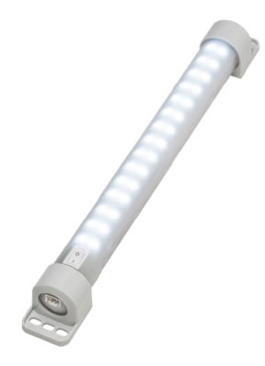
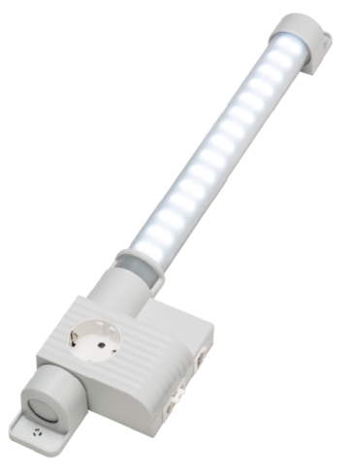

Caption:
Varioline LED 121 with module for socket and connection for external door contact switch (left), LED 021 Varioline lamp with on/off switch without socket (right).

STEGO - Perfect Thermal Management

Since it was founded in 1980, Stego Elektrotechnik in Schwaebisch Hall, Germany, has been developing, producing and selling an ever-growing range of products for the protection of electric and electronic components. All Stego products for cabinets and enclosures – heaters, fan heaters, filter fans, LED-lamps, thermostats, hygrostats and accessories - are aimed at reaching optimum climatic conditions in the most varied environments, ensuring that all sensitive components work reliably at all times. Stego is now represented at 12 locations and by more than 200 sales partners worldwide.

www.stego.de

Press contact:
Siegfried Oerthel | soerthel@stego.de | Tel. +49 791 95058-181
STEGO Elektrotechnik GmbH
Kolpingstrasse 21
74523 Schwaebisch Hall, Germany
Scan me for
STEGO NEWSROOM

