Press contact:  CONEC Elektronische Bauelemente GmbH Registered office:  Katja Schade  Phone: 02941/765-350  Fax: 02941/765-65 | Ostenfeldmark 16  D-59557 Lippstadt Germany  www.conec.com

Press release 1.01/2019

Title: Flexible and individual wiring almost without limits - CONEC connectors field-attachable; great variety from a single source
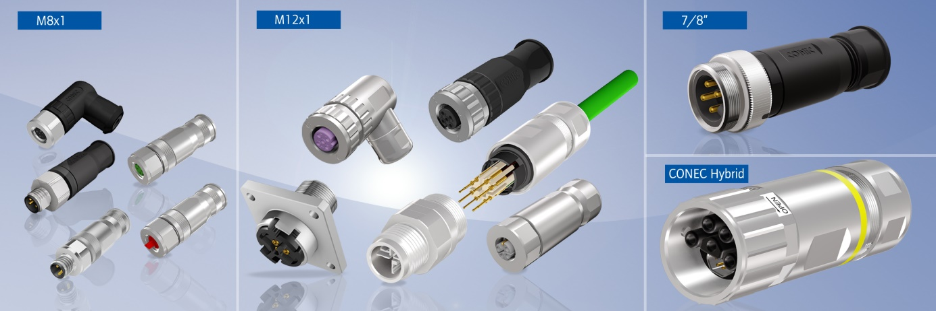
Caption: CONEC – Connectors field-attachable M8x1, M12x1, 7/8”, CONEC Hybrid

Progressively decentralized automation, keyword industry 4.0, requires flexible and individual wiring in certain areas directly in the field and at the machine. The constantly growing number of sensors for monitoring operating and machine conditions also necessitates the use of field-attachable connector variants that can be assembled to enable flexible electrical connections directly in the field.

CONEC offers field-attachable connectors with the following termination technologies.

"Screw termination" is probably the most widely used connection technology and can be easily assembled in the field using standard tools such as a screwdriver or a hexagon key which come with the product. The screw termination covers a wide range of terminal cross sections and allows the connection of flexible and rigid conductors. The screw termination is available for the connector variants M8, M12, 7/8” Rund24.

Crimp termination technology is preferably used in the transport industry and requires appropriate crimping tools for assembly to establish a reproducible, reliable connection. Different terminal cross-sections are also permitted for the crimp contacts, but in most cases 2 contacts with different crimp zones are required to cover the terminal cross section of a screw termination. Attachable connectors with crimp termination are available for the M8, M12 and
CONEC Hybrid series.

The connection technique using spring clamp technology can also be carried out in the field without requiring special tools. With a wide cross sectional range, this technology allows flexible wires to be connected to the connector. The spring clamp technology is available for the M8 and M12 connector series in standard coding A.

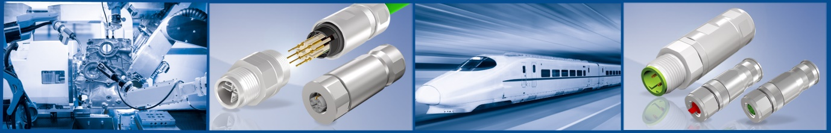

The connection techniques described above are used for the following CONEC series:

In the range of 7/8” and Rund24 connectors, which are primarily used for the power supply of distribution modules, field-attachable connectors with screw termination are available up to a cross section of 1.5 mm² for all numbers of poles.

CONEC M8 field-attachable connectors are available both as A-coded sensor connectors in 3- and 4-pos. versions and for the common industrial bus systems "EtherCat, EtherCatP and Industrial Ethernet" with screw terminations up to 0.75 mm² and with crimp termination up to 0.5 mm² wire cross section in straight version in unshielded and shielded versions.

For the M12 series, screw termination is available in standard codings in 4-, 5- and 8 pos. versions with straight and angled housing in shielded and unshielded versions.

The L-coded field-attachable connector M12 with screw termination up to 2.5 mm² is one of the newest products in this product range.

In addition, CONEC offers M12 connectors in A, B, D and X coding with crimp termination in shielded design with straight housing (X coding only as male connector). Different crimp contacts cover the range of wire cross-sections from 0.16 mm² to 0.5 mm². In addition to the cable connectors, the product range is completed by a field-attachable socket for rear panel mounting in 4-, 5- and 8-pos. A-coded male versions.

Our brochure "Overview Circular Connectors" Part. No. 790-700840 provides an overview of the sizes which are available for the respective connection technologies and number of poles.

The latest members of the range of field-attachable connectors by CONEC are CONEC Hybrid Connectors where power and data transmission are combined in one single connector, thus creating a single-cable technology that meets the latest requirements of connection and interface technology. CONEC Hybrid connectors are available with crimp termination technology in sizes B12, B17 and B23.

Product details:

Fields of application:
- Drive technology
- Medical
- Automation technology
- Industrial interfaces
- Assembly and production lines
- Cable assembly
- Process automation
- Communication
- Process control
- Machine manufacturing
- Transport industry

Benefits:
- Flexible and easy assembly in the field
- Various termination technologies
- 360° shielding of interference signals with shielded version
- Robust housing for use in harsh environments
- Compact design
- Short cable outlet for limited installation situations with angled
Version
- Protection class IP67
- RoHS - compliant
- Vibration-proof
- Vibration and shock resilient

