Press contact:  CONEC Elektronische Bauelemente GmbH Registered office:  Katja Schade  Phone: 02941/765-350  Fax: 02941/765-65 | Ostenfeldmark 16  D-59557 Lippstadt  www.conec.com

Press release 1.08/2020

Title: CONEC 7/8“-Connectors wire cross section 2,5 mm²-AWG14
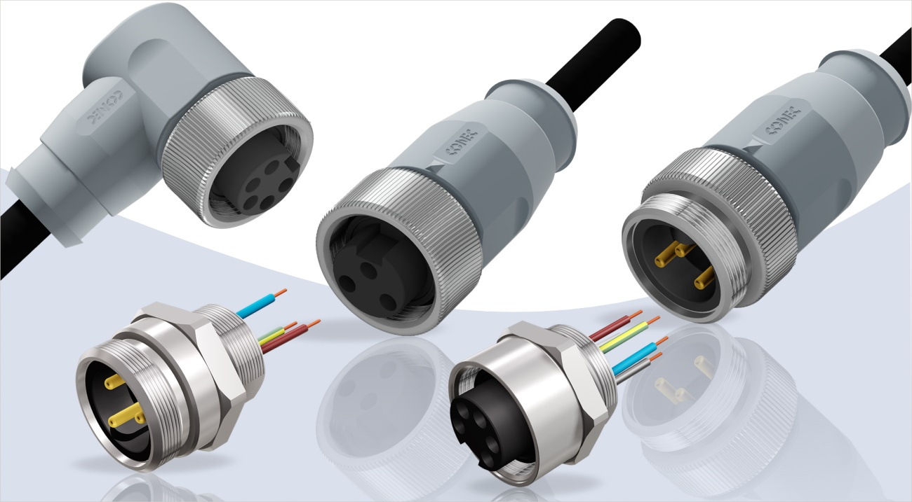
Caption: CONEC 7/8“-Connectors wire cross section 2,5 mm²-AWG14

For many years, circular 7/8“-connectors have been available for the requirements of the American market. In addition to overmoulded cable connectors, the product portfolio also includes field-attachable-connectors as well as flange connectors with strands or for direct PCB assembly.

In order to meet the increased demands for higher power transmission, the product portfolio of the 7/8” connectors has been developed with new variants of connectors overmoulded and sockets with wire connection. These versions have a stranded cross-section of 2.5 mm² instead of 1.5 mm², which gives a current load capacity of 16 A at an ambient temperature of 40°C.
The overmoulded connectors are available in axial and angled design with 2+PE as well as 4+PE and PVC as well as TPU cables. The flange connectors with strands are available in axial form for front panel mounting (male & female) and back panel mounting (male) , whereby other flange variants can also be offered on request.

Fields of application:
- Automation technology
- Industrial interfaces
- Agricultural and construction machines
- Machine manufacturing
- Process control
- Transport industry

Benefits:
- High power transmission
- Degree of protection IP67 (Sockets)
- Degree of protection IP68 (Connectors overmoulded)

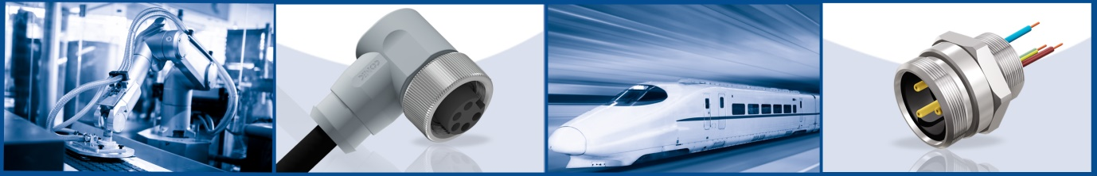

Productdetails:

