PRESS RELEASE
BD SENSORS GmbH
Gerald Rösel
BD-Sensors-Str. 1
95199 Thierstein

Phone: 0 92 35 / 98 11 2088
Fax: 0 92 35 98 11 11
gerald.roesel@bdsensors.de

Date: 08/06/2015
Press release: PM62015

presSURE WE CAN – optimal solutions from BD|SENSORS

Wherever pressure has to be measured or fill levels have to be monitored, the German pressure sensor specialist delivers tailored solutions in numerous application areas. This is demonstrated yet again by the launch of the new DPT 200.
The DPT 200 differential pressure transmitter from BD|SENSORS meets stringent precision requirements. It is intended for applications in the process industry and measures pressure with an accuracy of 0.075% FSO.
The DPT 200 differential pressure transmitter is specifically designed for process industry sectors, including the chemical, petrochemical, paper and oil & gas industries, and can be used to measure fill levels in closed pressurised vessels, monitor pumps and filter systems, and measure flow rates. It is available with measuring ranges from 0–1 mbar to 0–20 mbar, with static pressure ratings up to 400 bar. A turndown ratio of up to 100:1 testifies to the versatility of the DPT 200.
Another special feature is the optional backlit LC display, which simplifies device configuration and readout. In addition, the DPT 200 supports the HART® communication protocol.
To ensure optimal adaptation to individual applications, a variety of pressure transducers with various membrane materials, as well as capillary lines, can be attached to the transmitter.
The new DPT 200 is optionally available in intrinsically safe (Ex ia) and flame-proof (Ex d) versions for use in explosion hazard areas.
For more information, visit
www.bdsensors.de

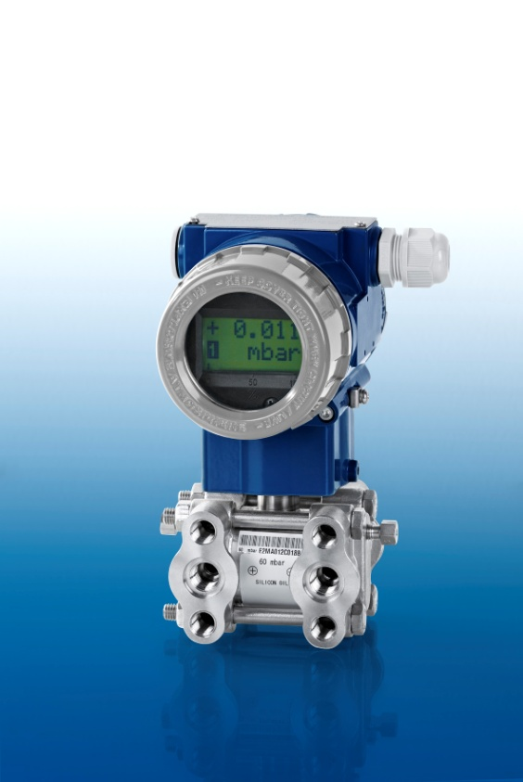
DPT 200

