Press Release 15SH15
SHW Aktuell June 2015
The oldest industrial company in the world comes from Wasseralfingen
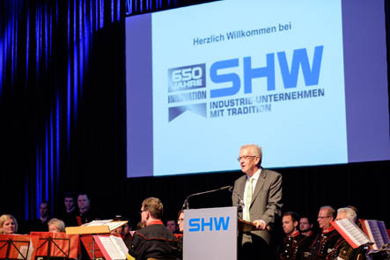
"Older than the Ulm Minster"
SHW celebrates 650 years of company history
Contact and information:
SHW Werkzeugmaschinen GmbH
Head of Marketing
Danny Basic
Tel. +49 7361 5578 813
Fax +49 7361 5578 900
danny.basic@shw-wm.de
Alte Schmiede 1
D-73433 Aalen
Text + Images under www.pressearbeit.org

(Aalen, 02.07.2015) The history of the Schwäbische Hüttenwerke, founded in 1365, was jointly celebrated in a large official ceremony on 25 June, 2015 by the successor companies; SHW Automotive, SHW Werkzeugmaschinen, SHW Bearbeitungstechnik, SHW Casting Technologies and SHW Storage & Handling Solutions GmbH. As Thomas Buchholz, Managing Director of SHW AG, emphasised in his welcoming speech, SHW has been in existence since before the construction of the Ulm Minster. What started out, with the granting of the imperial mining charter, as the eysenwerck (iron foundry), has developed into five technology leaders with a level of global significance. State premier Winfried Kretschmann and EU Commissioner Günther Oettinger praised the creativity, innovation and adaptability of the Swabian entrepreneurship and stressed the importance of SHW for the people in the region.
The speakers at the ceremony for SHW in Aalen-Wasseralfingen spanned an arch from iron smelting in the "eysenwerck" in 1365 to the current latest theme of "Industry 4.0". 650 years of achievement, with all its ups and downs, is certainly something worthy of the acknowledgement given by the successor companies of Schwäbische Hüttenwerke; SHW Automotive GmbH, SHW Werkzeugmaschinen, SHW Bearbeitungstechnik, SHW Casting Technologies and SHW Storage & Handling Services. During the ceremony marking the unique anniversary of the oldest industrial company in Germany, and probably in the world, congratulations were given by EU Commissioner Günther Oettinger, state premier Winfried Kretschmann, the historian Professor Weber and Aalen Mayor Thilo Rentschler.

Innovative power and versatility praised by Oettinger and Kretschmann
It is innovation that has always shaped the successful path of Schwäbische Hüttenwerke, stressed Oettinger. As European Commissioner for the Digital Economy and Society he encouraged the SHW companies to fully embrace the digital revolution, as the next innovation, because data is the oil of the future. Premier Kretschmann, as a representative of the State of Baden-Württemberg, which was a joint owner of SHW from 1921 to 2005, praised the versatility of the company and the spirit of the people in the region who, through their knowledge, creativity and free thinking over generations, have written an unprecedented corporate history. Reflecting the spirit of the 17th century political economist Ferdinand von Steinbeis, who once served an apprenticeship in Wasseralfinger ironworks, it is curiosity, creativity, education and knowledge that are always the "raw materials" which make such achievements possible. Mayor Rentschler and Prof. Weber emphasised the importance of the combined SHW companies for the region around Aalen-Wasseralfingen over the centuries. Both the inhabitants of the region and SHW have influenced each other throughout the years.
In addition to the prominent keynote speakers some 250 invited guests from politics, business and society celebrated this unique company anniversary together with SHW customers and business partners. Earlier on, the Managing Directors as well as shareholders of the SHW successor companies lead a question and answers session with representatives of the trade and local press. Afterwards the members of the press were able to examine the latest equipment and technologies close up in the SHW Werkzeugmaschinen production halls: Including a jubilee edition of the UniSpeed ​​5 machine, which is ornamented with elements of the original charter document and the word "eysenwerck" and is offered as a limited edition at an attractive price.

Festival guests celebrate granting of charter by Charles IV
An imperial charter granted by Emperor Charles IV (1316-1378) on April 14, 1365 allowed the Counts of Helfenstein, to extract iron ore from their lands in Heidenheim and to build the necessary facilities for iron smelting. This privilege of usage is regarded as laying the foundation stone of the Württemberg iron smelting industry and marks the birth of the Schwäbische Hüttenwerke (SHW). Over the succeeding 650 years, a unique and unprecedented history followed. Since its founding in 1365, the perpetual quest for leadership in technology and quality has long become part of the DNA of SHW. Through the dedication and commitment of its employees, SHW has always been able to extend the limits of technology and offer advanced product solutions and services.
As a result, all of the SHW successor companies are built on an economically sound footing. And since the entry of the investor Markus Hüter and his Restart GmbH & Co. KG, even the formerly troubled SHW Casting Technologies positively looks forward to a sustainable future.
590 words, 4,611 characters
For reprint please send two copies to SUXES
Text and Images under www.pressearbeit.org

SHW 650 year celebration image list,
with 2 clicks to text and image under www.pressearbeit.org.
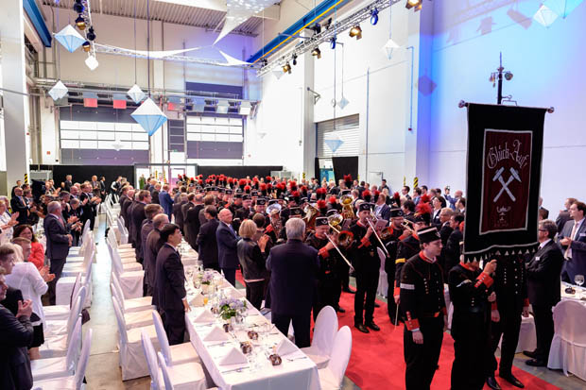
Image no. 15-01 SHW650_Bergkapelle.jpg
The official commemoration of the 650th anniversary celebration of SHW starts with the festive entrance of the SHW Bergkapelle.
Image source: © SHW, Jan Walford
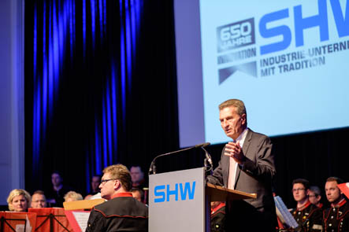
Image no. 15-02 SHW650_GOettinger.jpg
European Commissioner for the Digital Economy and Society encourages the SHW companies to fully embrace the digital revolution, because data is the oil of the future.
Image source: © SHW, Jan Walford
Image no. 15-03 SHW650_WKretschmann.jpg
Premier Kretschmann, as a representative of the State of Baden-Württemberg, praises the versatility of the company and the spirit of the people in the region who, through their knowledge, creativity and free thinking over generations, have written an unprecedented corporate history.
Image source: © SHW, Jan Walford
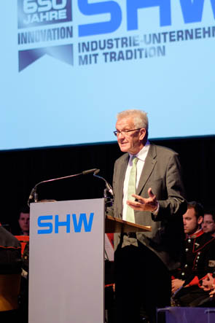
Image no. 15-04 SHW650_.jpg
Reflecting the spirit of the 17th century political economist Ferdinand von Steinbeis, who once served an apprenticeship in Wasseralfinger ironworks, Kretschmann notes that it is curiosity, creativity, education and knowledge that are always the "raw materials" which make such achievements possible.
Image source: © SHW, Jan Walford
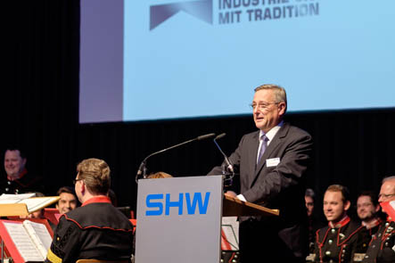
Image no. 15-05 SHW650_DrBuchholz.jpg
Dr. Thomas Buchholz, Managing Director of SHW AG, welcomed around 250 invited guests to the unique anniversary of the oldest industrial company in Germany, which was already in existence "before the Ulm Minster was built."
Image source: © SHW, Jan Walford
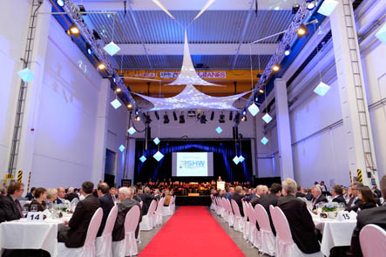
Image no. 15-06 SHW650_Totale.jpg
The history of the Schwäbische Hüttenwerke, founded in 1365, was jointly celebrated in a large official ceremony on 25 June, 2015 by the successor companies; SHW Automotive, SHW Werkzeugmaschinen, SHW Bearbeitungstechnik, SHW Casting Technologies and SHW Storage & Handling Solutions GmbH.
Image source: © SHW, Jan Walford
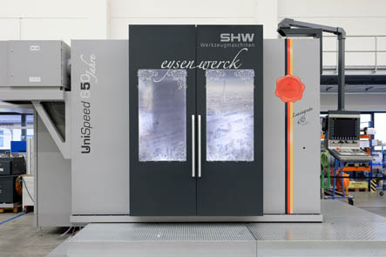
Image no. 15-07 SHW650_US-5-Jubi.jpg
Jubilee edition of the UniSpeed ​​5 machine, which is ornamented with elements of the original charter document and the word "eysenwerck"
Image source: © SHW, Jan Walford
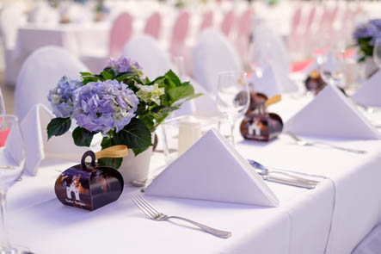
Image no. 15-08 SHW650_Impression.jpg
The evening was diversely organised - alongside official speeches the guests were treated to an attractive supporting program consisting of music (SHW Bergkapelle), an acrobatic display (a rope act and antipodes games), comedy acts and a diner menu.
Image source: © SHW, Jan Walford

Company information SHW Werkzeugmaschinen GmbH with SHW Bearbeitungstechnik
A young company with an ancient tradition
SHW Werkzeugmaschinen GmbH is a leading global manufacturer of machine tools for the machining of large parts. The machining centres with large traverses are used for production of large engines or parts, which must have a high degree of precision in spite of their huge size, for machinery and mould making, turbine and tooling production and for the aircraft industry. The subsidiary SHW Bearbeitungstechnik is also part of the company, in which SHW Werkzeugmaschinen holds 90 percent share. As a specialist in metal machining of large parts, SHW Bearbeitungstechnik manufactures high precision, complex components for the machine tool industry, general engineering and engine construction, as a classical toll manufacturer to customer order.
Consistent growth and a commitment to the Swabian location, with some 300 highly qualified and quality-conscious employees, have led to an annual turnover in current terms of around 70 million Euros. A presence in 45 countries ensures customer proximity worldwide.

