Press report 13SH14
Application at Maschinenfabrik Albert, A December 2014
The latest UniSpeed 7 from SHW Werkzeugmaschinen increases both flexibility and productivity at screw jack specialist, Maschinenfabrik Albert
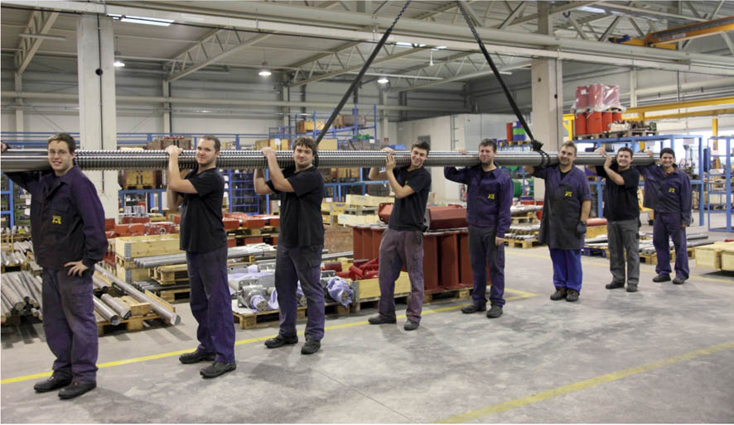
Gear units which move the world
Contact and information:
Manufacturer
SHW Werkzeugmaschinen GmbH
Danny Basic
Alte Schmiede 1
D-73433 Aalen-Wasseralfingen
Tel. +49 7361 – 5578 813
danny.basic[at]shw-wm.de
www.shw-wm.de
Operator
Maschinenfabrik ALBERT GmbH
an INKOMA Group company
Martin Kirchmaier
CEO
Technologiepark 2
A-4851 Gampern
Tel +43 (0)7682 3 90 90-0
martin.kirchmaier[at]albert.at
www.albert.at

Text + Images under www.pressearbeit.org
(Gampern, A/Aalen) As one of the leading manufacturers of screw jacks for a wide variety of applications Maschinenfabrik Albert from Gampern is known for its customer and application specific solutions. The products from Upper Austria act as the "pulsing heart" that moves many machines, assemblies and installations, such as large radio telescopes, oil platforms or theatre stages. The new UniSpeed 7 from SHW Werkzeugmaschinen provides increased productivity and flexibility in machining of large parts. This also benefits customers including one of the world's most renowned ballet companies.
"First-class machinery is essential for the manufacture of our customer and application specific screw jacks", emphasises Martin Kirchmaier, CEO of Maschinenfabrik GmbH Albert, which belongs to the Inkoma Group. "The new UniSpeed 7 from SHW Werkzeugmaschinen has advanced us enormously in the machining of large parts". It is not just the technical characteristics and pendulum machining that have impressed the Austrians but especially the fact that the machine is very rigid and free from vibration and is completely enclosed. This is of particular advantage to the manufacturer of safety-related gear units when it comes to moving the boards that capture the interest of the world. But first things first.

Great depth of production assures outstanding quality
Maschinenfabrik Albert manufactures high quality screw jacks in standard and special designs, which have established it as a leader in the field of mechanical drive technology. The Austrian company and member of the INKOMA Group since 2000 is known and appreciated for this capability throughout the world. Wherever something has to be moved, it is often Albert screw jacks that are responsible for making sure it happens; powerfully, reliably and with pin-point accuracy. This means that huge radio telescope antennas in the most inhospitable locations are adjusted with millimetre precision, oil production platforms are protected from the "champagne effect" and theatre stages are moved under the strictest health and safety authority requirements.
The manufacture of the individual components of a screw jack such as spindle, gear housing or swivel bracket are given top priority at Albert. "We place the highest value on the quality of each individual part," says Kirchmaier, "as eventually our products often have to work for decades in the harshest conditions, such as in the manufacture of paper."And this is the very reason why the company operates with a depth of production of around 90%. Since March 2014 Albert has relied on the latest product of SHW Werkzeugmaschinen from Aalen, East Württemberg, for the processing of large spindles, often several metres in length, and the associated housing.

Flexible productive work space
The new UniSpeed 7 has been designed from the start as a basic machine for large parts. Therefore large workpieces up to six metres in length can be machined quickly and precisely. The newly designed machine bed ensures even quieter and more stable operation. It is made in a single piece and filled with polymer concrete. This makes the machine extremely rigid and effectively suppresses vibrations. The single step to the mounting surface and an automatically opening operator door are part of an improved ergonomics concept making it easier for the operator to access.
The spindle transmits a very high torque of 900 Nm. "Compared with machines of a similar order of magnitude it is almost unique," says Martin Rathgeb, Technical Director and Company Secretary of SHW Werkzeugmaschinen GmbH. The workspace extends to 6000 mm in the X-axis, to 1600 mm in the Y-axis and to 1300 mm in the Z-axis. However, the machine does not necessarily need a contour foundation.

Ergonomics concept takes into account operators' health
In addition, the resourceful designers of SHW Werkzeugmaschinen have optimized the chip flow. A machining area extraction unit extracts the vapours and spray mist from the machining area and provides not only healthier working conditions but also improved visibility into the machining area. "Above all, we were impressed by the cleanliness inside and around the machine and the ergonomic access with just one step," noted Kirchmaier.
At Albert the machine is equipped with two integrated rotary tables for pendulum operation with parallel runtime setup option. On the one hand this increases the working range within the still relatively compact dimensions of the machine. This enables the whole of the machining area to be fully utilised for longer parts. And on the other hand it allows the option of partitioning through a divider for parallel runtime setup, with the greatest savings in time. As Rathgeb comments, "It makes for great productivity gains in daily operations".

Increase productivity through parallel runtime setup
The machine has an automatic tool changer and a pick-up station for tools. The novel orthogonally designed SHW universal milling head picks-up and changes them automatically in an instant. The compact and powerful orthogonal milling head has been the core of SHW machine tools for over 50 years and due to its agility it can approach the workpiece quickly and precisely from more than a calculated 216,000 positions. As a result of the 180° A-axis rotation and the 360° continuous variable C-axis, as employed on models with the head changing system, the compact head swivels fully automatically in any desired position.
The UniSpeed 7 is the first SHW machine with the new Siemens 840D SL (Solution Line) control. As Christian Hühn, managing partner of SHW-Werkzeugmaschinen, emphasises: "Even in the entry-level version, the new UniSpeed 7 is a highly efficient machine for processing large parts at an attractive price". Overall, the concept offers high flexibility and efficiency in machining. This is also confirmed by Kirchmaier, who is particularly impressed by the 5-sided machining in one setup and the high dynamics of the liquid-cooled drives on all axes.

Special designs as standard
This is therefore how machined workpieces, which subsequently become high quality, distinctive screw jacks, are produced to the required precision at Albert. In the basic version of a SGT screw jack for example, the screw mechanism, swivel bracket and housing as well as the motor flange, spindle ends and other components must be precisely manufactured for extended durability and trouble-free operation. For the travelling nut versions, the swivel housing as well as the running and safety nut are also added. Albert screw jacks are available with manual, hydraulic, pneumatic and electronic drives, with spindle lengths up to ten meters, lifting capacities up to 2000 kN and lifting speeds up to 0.05 m/s. In addition however, dependent on customer requirements and application conditions, the Austrian company manufactures products with higher lifting speeds and from special materials for increased mechanical and chemical demands as well as with ball or acme screw threads.
The ability of Albert products to meet these qualitatively high demands has already been proven in numerous applications. This also includes safe operation at ambient temperatures from -50°C to 200°C. Radio telescope antennae with great weight and expensive precision mirrors, costing tens of millions of Euros, therefore move reliably and with pin-point accuracy in ice and snow as well as in hot weather. In the paper industry they stand up to extremely tough and sticky raw materials. Here 150 synchronously operated gear units adjust the lips that determine the paper thickness. When an oil rig in the North Sea was being cut under water for sending to scrap, Albert screw jacks prevented the upward buoyancy from forcing the oil rig up like a champagne cork. Instead, the buoyancy was controlled and the platform could be safely towed ashore.

Drive technology for fine arts as well as brute force
However the Austrian drive technology is not just in demand for sheer brute force, even in the fine arts the show cannot go on without them. Which is why the star ensemble of the Bolshoi Theatre in Moscow is delighted with a multi-adjustable theatre stage, which allows it to present the full range of its artistic skills with great audience appeal. The necessary personal safety is ensured by specially sealed screw jacks with an electrically supervised safety nut and a mounted geared limit switch. This special stage version meets the health and safety standard BGV C1 / DIN 56950-1 for theatre stages as well as VBG 14 for (industrial) lifting equipment with people on/under load, equivalent to EN 1493. And as Mr Martin Kirchmaier noted in summary: "Thanks to SHW everything now meets our expectations for productivity in production".
1,116 words, 8,816 characters
For reprint please send two copies to SUXES
Text and Images under www.pressearbeit.org

((Company Info SHW Werkzeugmaschinen GmbH))

A young company with an ancient tradition
SHW Werkzeugmaschinen GmbH is one of the world's leading manufacturers of machine tools for the machining of large parts. The machining centres with large traverses are used for production of parts, which must have a high degree of precision in spite of their huge size, for machinery and mould making, turbine and tooling production and for the aircraft industry. What started as a young and innovative company in Aalen-Wasseralfingen in 1999, strictly speaking drew its inspiration from a tradition in industrial technology that dates back to 1365. Consistent growth and a commitment to the Swabian location, with some 200 highly qualified and quality-conscious employees, have led to an annual turnover in current terms of around 63 million Euros. A presence in 45 countries ensures customer proximity worldwide.

((Company Info Maschinenfabrik GmbH Albert))

Quality conscious with great depth of production
The ALBERT Maschinenfabrik Company was founded over 65 years ago and since 2000 has been wholly owned by the INKOMA Group. With the production of high quality screw jacks in standard and special designs ALBERT has developed a leading position in the field of mechanical drive technology. In modern production facilities of 6000 m², with a great depth of production, application and customer specific products and solutions are manufactured, which enjoy the highest recognition worldwide. Screw jacks, which operate with a high level of safety in temperatures from -50°C to 200°C, are used in the paper industry, food industry, theatre and stage design, storage and transportation, shipbuilding, rolling mill and foundry engineering, civil engineering, research and new technologies.

SHW WM Image list, Application Albert
with 2 clicks to text and image under www.pressearbeit.org.
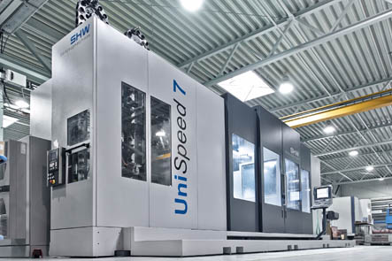
Image no. 13-01 SHW_AB-UniSpeed7.jpg
As a leading manufacturer of screw jacks for a wide variety of applications Maschinenfabrik Albert puts the new UniSpeed 7 from SHW Werkzeugmaschinen into operation.
Image source: © Jan Walford
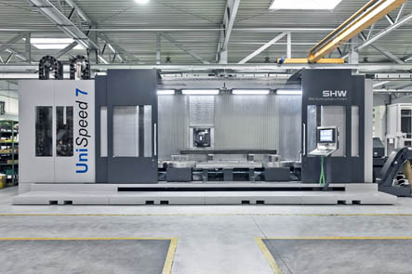
Image No. 13-02 SHW_UniSpeed-7.jpg
New UniSpeed 7 from SHW Werkzeugmaschinen: an innovative basic machine for machining large workpieces up to six meters in length.
Image source: © Jan Walford
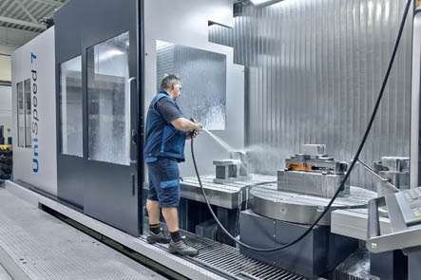
Image No. 13-03 SHW_AL-US7-Zugang.jpg
As part of the improved ergonomics concept the new UniSpeed 7 from SHW Werkzeugmaschinen allows the operator access to the mounting surface with only one step.
Image source: © Jan Walford
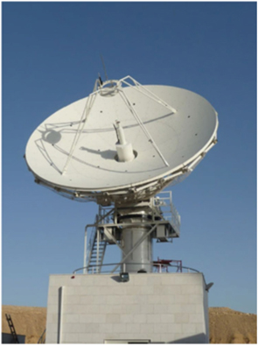  Image no. 13-04 SHW_AL-US7-RTeleskop.jpg  Albert screw jacks move radio telescope antennas with great weight and expensive precision mirrors costing tens of millions of Euros reliably and with pin-point accuracy in ice and snow as well as in hot weather. | 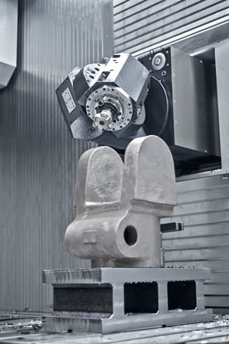  Image no. 13-05 SHW_AL-US7-Fräskopf.jpg  The compact and powerful orthogonal milling head has been the core of SHW machine tools for over 50 years and reaches the workpiece quickly and precisely from more than a calculated 216,000 positions.  Image source: © Jan Walford
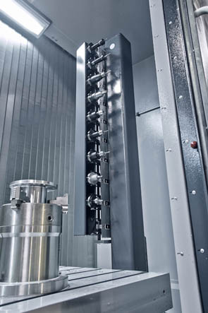  Image no. 13-06 SHW_AL-US7-PickUp.jpg  The UniSpeed 7 has an automatic tool changer and pick-up station for tools.  Image source: © Jan Walford | 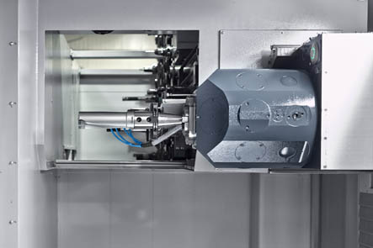  Image no. 13-07 SHW_AL-US7-.jpg  The unique SHW orthogonal milling head retrieves tools automatically and changes them quickly.  Image source: © Jan Walford
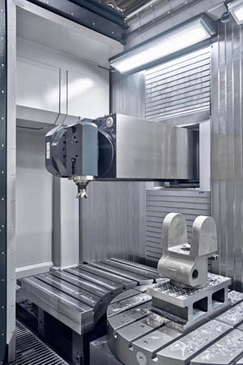  Image no. 13-08 SHW_AL-US7-Z-Achse.jpg  The workspace of the new UniSpeed 7 extends to 6000 mm in the X-axis, to 1600 mm in the Y-axis and to 1300 mm in the Z-axis.  Image source: © Jan Walford | 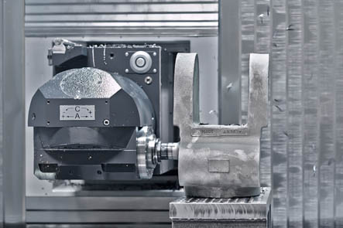  Image no. 13-09 SHW_AL-US7-Fräskopf2.jpg  SHW Werkzeugmaschinen has optimized the chip flow and a machining area extraction unit extracts vapours or spray mist.  Image source: © Jan Walford
Image no. 13-10 SHW_AL-US7-LängsteSpindel.jpg
The largest spindle manufactured by Maschinenfabrik Albert with nearly 12 m in length and 160 mm in diameter.

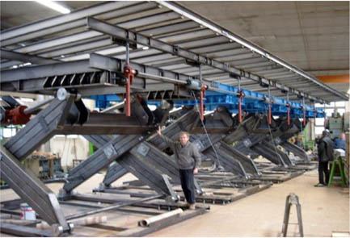
Image no. 13-11 SHW_AL-US7-Theaterbühne.jpg
The star ensemble of the Bolshoi Theatre in Moscow is delighted with a multi-adjustable theatre stage.
Image source: B+P Veranstaltungstechnik GmbH
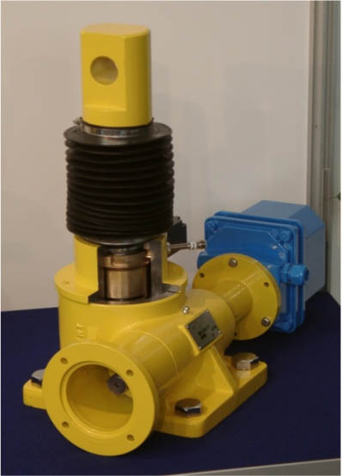
Image no. 13-12 SHW_AL-US7-TheaterbühneSGT.jpg
This special stage version meets health and safety standards according to VBG 14 and BGV C1.
Image source: MF Albert

